INTRODUCTION TO ECONOMICS:
Economics is concerned with the problems of how best man can make effective use of the available resources and distribute the output amongst different economic entities in society.
Others look at economics as a practical science that studies wealth of nations, or how man earns his living, or how resources are allocated to meet alternative ends.
Classical economists look at economics as a science of accumulation of wealth.
According to Robbins, it is a science which studies human behaviour as a relationship between ends and scarce means which have alternative uses. This definition has been widely accepted even by modern economists because:
- It studies how best man can allocate the scarce resources to satisfy as many wants as possible.
- It recognizes human wants to be unlimited yet resources to satisfy them are limited.
- It emphasizes the need to make correct choices when allocating the scarce resources, hence the concept of opportunity cost.

Why study Economics?
- To understand how scarce resources are put into better use.
- To understand the functioning of the business world.
- To enhance further academic and professional studies.
- To encourage effective participation in the process of development of the economy.
- To understand basic economic concepts and principles so as to acquire basic skills that will help one to be prepared to face challenges of life.
- To understand and appreciate economic problems of society and to be able to interpret these problems and possibly advise government and policy makers.

TYPES OF ECONOMICS:
Positive economics deals with testable statements that look at the world as it is, or what it was or what it will be. Examples include, when the price of a good increases, the supply for it increases, excessive issuance of currency may lead to inflation, economies of developing countries are predominantly agricultural, etc.
Normative economics deals with imaginary ideas that look at the world as it ought to be. It depends on peoples opinion and speculation. Examples include, in two years time, unemployment will be no more in Uganda, and all households in Uganda will have safe clean drinking water by 2030. Etc.

BRANCHES OF ECONOMICS:
Micro economics, this is the study of individual economic units in an economy, e.g. consumers, firms and resource owners.
Macro economics, this is the study of collective or aggregated behaviours and averages covering the entire economy. Examples include National income, inflation, aggregate demand, total employment, total savings, aggregate supply, National budget etc.

FUNDAMENTAL ECONOMIC PROBLEMS:
- Scarcity, this refers to the limitedness of resources to satisfy the unlimited human wants at a particular time. It implies that resources are in short supply relative to peoples desire for them.
- Choice, this is an economic decision made by individuals in order to satisfy their unlimited wants using the scarce resources at a particular time.
Uses of choice
Determines what to produce
Determines how to produce
Determines where to produce
Determines when to produce
Determines how much to produce
- Opportunity cost, this refers to the alternative foregone when choice is made.

How are the fundamental economic problems related?
Due to limited supply of resources to satisfy the unlimited human wants (scarcity), an individual is forced to make an economic decision (choice), and by making that economic decision, some wants are foregone at the expense of others (opportunity cost).

Uses of opportunity cost:
- It is used by producers in pricing of goods and services.
- It is used by producers in making production decisions.
- It is used by producers in pricing factors of production.
- It is used by the government in determining which sector to develop first.
- It is used by the country in determining which commodity to produce and export in international trade (comparative advantage).
- It is used by producers in determining wages for workers.
- It is used by consumers in making their consumption decisions.
State any three circumstances under which the concept of opportunity cost can be used in economics? (2003-p.1)

Fundamental economic questions:
What to produce? This is a result of scarce resources implying that, there must be choice between the alternative goods and services that might be produced.
Where to produce? This is concerned with the location of the production unit, whether the industry should be located near the source of raw materials, or near the market.
When to produce? The society is faced with the choice of having production for present consumption or delaying production and having more goods and services later.
How to produce? There must be a decision on what technique to use in production and this decision is basically dependent on the labour skills and capital equipment used.
For whom to produce? A decision must be made about who must receive the goods and services produced. However, this depends on the extent to which the individuals in the country are free to choose their own basket of goods.

Transformation curve/ Production possibility frontier/ Opportunity cost curve: (2005-p.1)
It is a locus of points showing two commodity combinations that a country can produce when all the available resources are fully and efficiently utilized given the level of technology. OR
It is a locus of points of maximum output level of two goods when resources are fully utilized using a given desired level of technology.
Assumptions underlying the ppf curve:
- It assumes that resources available are fully and efficiently utilized.
- It assumes that the economy produces only two commodities.
- It assumes constant technology.
- It assumes a closed economy.

An illustration of the PPF curve:

Points that lie along the curve (A, B, C, D) show that resources are fully and efficiently utilized.
Point E indicates under utilization of available resources.
Point F is desirable but unattainable.

Causes of outward shift of the transformation curve:
- Discovery of new natural resources.
- Improvement in the level of technology.
- Increase in labour skills.
- Increase in labour force.
- Increase in capital inflow.
- Expansion of market.
- Increase in entrepreneurial skills.
- Improvement in infrastructural development
Quiz.
1. Give the factors that lead to the shift/change of the PPF curve.
2. Under what circumstances may the PPF shift to left?
The transformation curve illustrates the following concepts in economics:
- Scarcity and choice, a country cannot produce beyond its production possibility frontier because of scarcity of resources, therefore, there is need to make choice on what to produce and how much of each commodity to produce using the scarce resources.
- Opportunity cost, this is illustrated by the movement along the curve e.g. from point B-A. If a country desires to produce more of commodity X, it has to forego some units of commodity Y.
- Efficiency in production, points A, B, C, and D show efficient utilization of resources while point F is desirable but unattainable, and point E inside the curve shows under utilization of resources.
- Economic growth, this is illustrated by the shift of the production possibility curve outwards. However the shift of the curve inwards shows negative economic growth.

HUMAN WANTS:
These are desires (needs) that individuals wish to achieve in order to live.

Types of human wants:

Basic human wants, these are desires/ needs which are essential and necessary for human existence, e.g. food, shelter, clothing.

Secondary wants, these are desires which are not very essential or necessary for survival of human beings, but the satisfaction of such wants improves the standard of living and make life comfortable, e.g. phones, cars, computers etc.

Some wants may be material (these are desires that can be satisfied by the consumption of goods) or immaterial (these are desires that can be satisfied by consumption of services other than tangible commodities).

Characteristics of human wants:
- They are unlimited.
- They are competitive.
- They are dynamic.
- They are insatiable.
- They are complementary.
- They vary in urgency and intensity.
Define the term human wants.
Give any three characteristics of human wants.

SCALE OF PREFERENCE:
This is a list of wants arranged in order of priority starting with the most pressing needs to the least pressing ones.
It is important in economics because it helps one to make the best choice given the scarce resources.
It helps one in budgeting/ avoids impulse buying.

Types of goods:
- Economic goods (2008-p.2) are those that are scarce relative to their demand and they possess money value.
Characteristics of economic goods
- They arise out of scarcity.
- They possess money value.
- They provide utility.
- They involve an opportunity cost.
Quiz. Give any four reasons why Leisure is regarded an economic good.

- Free goods (2008-p.2), are those that exist in natural abundance and are consumed at zero price, e.g. sunshine, air, rain e.t.c.

- Public goods (2008-p.2), are those which when provided (usually by the state) for a particular group or individuals becomes available for others to use at zero or no extra costs and consumption by one person does not reduce the amount available to other users. E.g. defence, roads, street lights, street clocks e.t.c.

Characteristics of public goods:
- They are mainly provided by the government.
- They are non-excludable (used by all people).
- They are indirectly paid for.
- They are non-rivalry (no competition).
- Private goods (2008-p.2) are those which are enjoyed exclusively by private individuals.
- Merit goods (2005-p.2) are those, consumption of which is deemed desirable and are meant to improve the quality of life of the people. E.g. Education, Health Care, Safe Water, Transport etc.
- Demerit goods, are those which do not contribute to societys welfare and they may prove to be harmful and dangerous to consumers e.g. cocaine, cigarettes etc.
- Capital goods (producer goods) are those that are used in the production of other goods e.g. machines.
- Consumer (final) goods are those which have reached their final stage and are ready to be used by the final users.
- Intermediate goods, are semi-processed goods that are used in the production process to make final goods. E.g. steel, wheat flour, sugar, maize flour, cotton lint, leather, salt etc.
- Necessity goods, are those which are essential and needed for human existence e.g. food, clothes, shelter e.t.c.
- Luxuries/ goods of ostentation/ snob appeal are those of high quality which are usually consumed by high income earners and their demand increases with increase in their price. E.g. expensive cars, expensive jewelry etc.
- Giffen goods, these are cheap commodities usually food stuffs whose consumption increases with increase in price and decreases with decrease in price. E.g. cassava, sweet potatoes etc.
- Inferior goods, these are low quality goods whose demand decreases with increase in consumers income.
- Normal/ superior goods are those whose demand increases with increase in consumers income.
- Substitute goods/ competitive goods, are those which can be used instead of others/ are those which serve the same purpose and their demand is competitive. E.g. coffee and tea, nomi and omo, close up and Colgate etc.
- Complementary goods are those that are used together. The demand for one increases the demand for the other e.g. cars and fuel, guns and bullets etc.
- Single use goods, are those which are used once and for all.
- Durable goods, are those capable of giving longer services to the final users e.g. machinery, buildings, furniture etc.
- Perishable goods, are those whose capacity to satisfy human wants ends immediately after use e.g. fresh milk, bread, meat, vegetable, etc.

Other concepts in economics:
- Wealth, this is a stock of goods/ physical assets possessed by an individual, firms, or government in a given period of time.
Characteristics of wealth:
- It provides utility.
- Ownership of wealth is transferable.
- It is scarce.
- It possesses money value.
Types of wealth:
- Private/personal wealth, this consists of physical assets that satisfy an individual owner in a given period of time. Or it is one in form of assets that satisfy individual needs of a person in a given period of time.
- Business wealth, this consists of physical assets that are owned by business enterprises in a given time period.
- Social/public/collective wealth, this consists of physical assets owned by the state and are meant to benefit all citizens in a country in a given time period.
- Resources, These are factor inputs or factors of production that are used to produce goods and services e.g. labour, land, capital, entrepreneurship.
- Utility, this refers to the satisfaction derived from the consumption of goods and services.
- Disutility, this refers to the satisfaction lost after consuming a given commodity.
- Ceteris paribus, this is a Latin word which means keeping other factors constant. It is a concept in economics which means holding other factors which may affect a given economic variable constant.
- Laissez-faire, this is a French word meaning leave us alone. It refers to an economic system where resource allocation, control and ownership is done by private individuals with limited or no government interference.

ECONOMIC SYSTEMS:
This refers to an institutional arrangement which determines the ownership, control and allocation of resources.

Types of economic systems:
Laissez-faire/ Unplanned/Capitalist/Free enterprise/Market economy (2011-p.1)
This is an economic system where productive resources are individually owned and the allocation and control of all these productive means is by the free inter-play of the market forces of demand and supply (Invisible hands) with limited or no government control.
Characteristics/ salient features of a Capitalist Economy:
- There is limited or no government intervention in resource allocation and ownership.
- The aim of the producers is production for profits.
- Consumers aim at maximizing utility.
- Prices of goods and services are determined by market forces of demand and supply.
- There is freedom by private individuals to accumulate wealth.
- There is freedom of entry of firms into production and freedom of exit of firms out of production.
- There is existence of consumer sovereignty- this is where the consumer is regarded as a king in resource allocation as regards to the answering of different economic questions.
Limitations to consumer sovereignty:
- Presence of monopoly power.
- Resale price maintenance
- Rationing of commodities.
- Price control (done by government).
- Presence of strong producer associations e.g. OPEC.

Merits of a Free Enterprise Economy:
- There is increased efficiency in production and this is achieved through the profit motive.
- There is improvement in quality of final goods because of increased competition among producers.
- There is limited wastage since production is according to demand due to the existence of consumer sovereignty.
- A wide variety of goods may be availed to the consumers. The desire for higher profits may encourage diversification and hence the production of different products.
- Consumers may buy goods at lower prices. This may be the result of price wars, which are associated with competitive production.
- There is full exploitation of resources due to the need to increase profits. This results into creation of more employment opportunities.
- It is a cheap system because of automatic allocation of resources using the invisible hands and there is no need to employ an external body to monitor the process of production since production is according to the consumers demand.
- It encourages private investment in the country since private individuals are free to own and allocate resources.
- It reduces the bureaucratic tendencies and other administrative weaknesses of the government in resource allocation. This ensures quick production.

Demerits of a Free Enterprise Economy (2011)
- Public goods such as roads, defence, and water supplies cannot be adequately provided for through the market system. This is mainly because there are unprofitable and expensive.
- There is unemployment when inefficient firms are pushed out of production process due to competition.
- There is exploitation of consumers by profit oriented producers who charge high prices.
- It worsens the problem of income inequality among individuals because of the freedom to accumulate wealth by private individuals.
- It encourages the production and consumption of harmful and dangerous commodities which fetch high prices since private producers aim at maximizing profits.
- There is creation of private monopoly due to inefficient firms being pushed out of production as a result of competition. This exposes consumers to exploitation.
- There is over exploitation of resources inform of overfishing, over mining, deforestation, since private producers aim at profit maximization.
- There is misallocation of resources towards the production of goods of ostentation for the rich at the expense of cheap necessities for the majority poor due to the desire to maximize profits.
- Excessive competition may lead to inefficiency and wastes as small firms may not be able to secure the advantages of large scale production. Competitive advertising also leads to wastage of resources.
- It is difficult to make rapid structural changes in the economy since there is limited or no government interference in resource allocation.

THE COMMAND/ SOCIALIST/ CENTRALLY PLANNED ECONOMY:
This is an economic system where resources are owned, controlled and allocated by the government. Economic decisions regarding what to produce, when to produce, and answering of different economic questions are made by the central planning authority.

FEATURES OF A COMMAND ECONOMY:
- Economic/ productive resources are publically owned.
- There is limited competition in production due to lack of profit motives.
- Production is for welfare maximization rather than profit maximization.
- There is no consumer sovereignty.
- Prices of goods and services are determined by the state through price control.
- Limited private investors since most investment ventures are publically owned.

Merits of a Command Economy:
- It ensures that adequate resources are devoted to production of public goods such as defence, roads which are not provided for by the private sector.
- It controls the production and consumption of demerit goods by banning their production and setting restrictions as well as health warnings to the consumers.
- It expands employment opportunities due to increased investment by the government. This improves welfare.
- Consumer exploitation inform of setting high prices and selling fake products is controlled by the government through setting a maximum price.
- It ensures equitable distribution of incomes and wealth through adopting a progressive taxation system.
- The under privileged people in society such as the disabled, the poor, are better catered for by the state through the provision of special institutions.
- It uses its monopoly powers in the public interests by securing advantages of large scale production, rather than make maximum profits by restricting output.
- A socialist economy can undertake provision and establishment of strategic enterprises which may not be easily undertaken by the private sector, for example central banking.
- It controls resource waste through over exploitation and; meaningless competition because of planned use of these productive resources.
- It is easy for a socialist economy to attain systematic and planned development since the economy can easily cope with rapid structural changes due to the existence of a central planning authority.
Defects of a Socialist Economy
- There is production of low quality goods and services due to lack of competition.
- There is limited variety of goods produced since the governments interest is in providing the basic necessities of life.
- Individual or personal initiative and effort is discouraged because of government ownership of resources.
- It is associated with bureaucracy and red tape which delays production and planning.
- There is wastage of resources as a result of over production or under production since there is no consumer sovereignty.
- The government tends to spend a lot of money on many planning officials who are required to plan and allocate resources. However, this results into high costs.
- It encourages corruption and embezzlement of public funds due to the absence of private ownership of resources.

A Mixed Economy :( 2012-p.1)
This is an economic system where resources are owned and controlled by both the government and private individuals. This system combines the features of both the free enterprise and a centrally planned economy.

Characteristics of a mixed economy:
- Economic decisions regarding resource allocation are made by both the government and private individuals.
- Resources are owned by both the state and private individuals.
- Production is for both profits and welfare maximization.
- There is existence of indicative planning. (This is a type of planning where the central government draws up plans, provides the necessary information and incentives to the private sector without interfering in their affairs.
- There is regulated competition in production and consumption.
- There is co-existence of private and public sectors.

Advantages of a Mixed Economy: (2012-p.1)
- Better quality products are produced because of competition between the private and public sectors.
- There is limited resource wastage due to regulated competition.
- There is a high level of employment of resources and labour by encouraging private investment through incentives.
- Reduced income inequalities since the government can intervene by taxing the rich highly while subsidizing the poor.
- There is economic stability due to government intervention through regulating prices.
- The public sector provides essential services that the private sector would not provide.
- Individuals self interests are regulated e.g. over exploitation of resources because government can intervene to set laws regarding resource exploitation.
- There is production of a wide variety of products since both the private and public sectors are involved in production.

PRICE THEORY:
This is concerned with the study of prices of goods and services.
Price is the exchange value of a commodity in terms of money in a given period of time. (2002-p.2) OR
It is the amount of money that has to be paid for a specific quantity of a commodity in a given period of time.
Uses of price: (2000-p.2)
- It guides producers on what to produce.
- It measures the value of goods.
- It is used by consumers in making consumption decisions.
- It determines how to produce.
- It is used to determine income distribution.

Price determination:
How is price of a commodity determined in a laissez faire economy? (2008-p.1)
Prices in Uganda are determined through the following ways:
- Through haggling/ bargaining, this involves negotiation of the price of the commodity between the buyer(s) and the seller until a suitable price is reached.
- By auctioning/ Bidding, this is where there is one seller and many prospective buyers who compete among themselves by offering different bids and the highest bidder takes the commodity.
- By sales through treaty, the market price may be set through agreements or treaties say by, the formation of commodity agreements. E.g. international coffee agreement.
- By forces of demand and supply, the price is determined by the free interaction of the market forces of demand and supply. The price at which the forces of demand and supply interact is known as equilibrium price.
- By price leadership/ imperfect collusion, this is common under oligopoly firms whereby either the dominant firm or a low cost firm sets the price for others to follow.
- Collusive pricing/ Cartel/ Perfect collusion, this is where firms under oligopoly come together inform of an arrangement to determine the price and output.
- Offers at fixed prices by individuals, institutions and government. This is where the price set by the seller is not subject to bargaining by the consumer.
- Resale price maintenance (2000-p.2), this is where the manufacturer sets the price at which retailers should sell the commodity to the final consumers. It is common with goods such as News papers, Airtime cards, postage stamps etc.
Advantages of Resale Price Maintenance:
- It protects consumers from producer/retailer exploitation.
- It maintains price stability.
- It saves time since there is no haggling. (Price is already fixed)
- It is easy for the manufacturer to estimate how much revenue he is likely to get.
- It enables the consumers to budget their income.
- Government policy of price legislation, this refers to the government policy of intervening in a free market situation by fixing price either above or below the equilibrium price. When government sets the price above equilibrium price, the set price is known as minimum price (price floor/guaranteed/intervention price) below which it is illegal to sell (it protects producers).
When government sets the price below equilibrium price, the set price is known as maximum price (price ceiling) above which it is illegal to sell (It protects consumers).

An illustration of Minimum price and Maximum price:

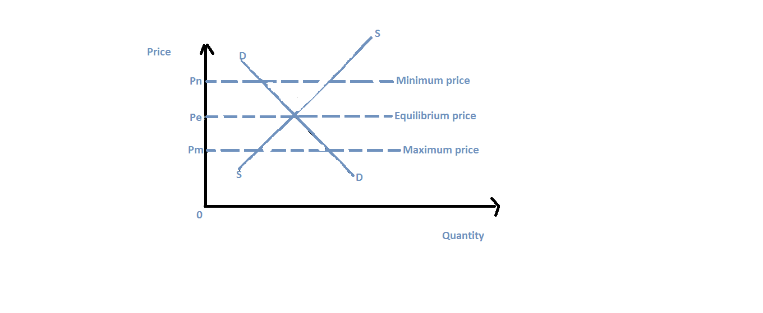
Maximum price legislation is the setting /fixing of prices of commodities by the government below the equilibrium price above which it becomes illegal to sell or buy the commodity. It protects consumers.
WHEREAS
Minimum price legislation is the setting of prices of commodities by the government above equilibrium price below which it becomes illegal to buy or sell the commodity. It protects producers.
Reasons for setting a Minimum Price
- To protect weak producers from exploitation by strong buyers.
- To control price fluctuations of commodities therefore make an economy attain price stability.
- To discourage the consumption of certain commodities e.g. harmful commodities.
- To stimulate investment, increased production and therefore effective use of the idle resources.
- To reduce importation of foreign products and thus correct any imbalance in the balance of payments.
- To minimize exploitation of labour by employers through setting a minimum wage (a minimum wage is one set above the equilibrium wage and it is illegal to pay workers below).
- To encourage creativity and innovativeness in production.

Demerits of Minimum Price Legislation:
- It causes excess supply in the market due to increased production, and this leads to wastage of resources since not all the output is demanded, thus storage problems.
- It encourages price increase hence inflationary tendencies.
- Consumption reduces as many consumers find it difficult to afford the goods whose prices have been legislated.
- There is over exploitation of resources by producers in an effort to increase production.
- There is an increase in the cost of production as a result of setting a minimum wage.
- It is expensive for the government to enforce because of the high administrative costs involved.
- It distorts the working of price mechanism and this may lead to inefficient allocation of resources.

Reasons for setting a maximum price:
- To protect consumers from exploitation by profit oriented producers.
- To encourage price stability and therefore minimize unnecessary price hikes.
- To discourage production of undesirable commodities e.g. demerit goods.
- To encourage the consumption of essential commodities since the price is favourable.
- To regulate monopoly tendencies, as monopoly to a greater extent is a price maker.
- To control dumping in the economy due to the existence of a low price.

Disadvantages of maximum price:
- Excess capacity occurs, as a number of resources are not put into proper use.
- It creates shortages of commodities, since the legislated price tends to be less attractive to producers.
- It encourages malpractices such as smuggling, hoarding, and black market as sellers become more selective.
- It reduces the level of investment and production, as profit margin reduces.
- Rationing of commodities occurs due to excess demand for commodities.

Distinguish between price ceiling and price floor
What are the likely effects of price control in an economy?
Merits of price control:
- It protects consumers from producer exploitation especially where a maximum price is set.
- It maintains price stability, thereby controlling inflationary tendencies and price fluctuations.
- It protects weak producers from exploitation by strong buyers through setting a minimum price.
- Price controls make commodities available to all groups of consumers in the economy by setting a maximum price.
- Price control enables producers to have stable incomes, and this facilitates planning.
- It establishes industrial peace which leads to increased efficiency of workers through setting a minimum wage.
- It stimulates investment and production in an economy, and this leads to expansion of employment opportunities. This is due to the setting of a minimum price.
- Price control may discourage the consumption of undesirable commodities which may even be dangerous to human life; this is as a result of setting a minimum price.
- It discourages production of some commodities especially those which are undesirable to our health; this is through setting a maximum price.
- It encourages creativity and innovativeness in production because of the profit motive; this is due to the setting of a minimum price.
- It enables an economy to off-set (recover from) an economic depression/recession due to setting of a minimum price. This is because it promote investment and production
- It reduces income inequality/ wage differentials through setting of a minimum wage. This increases the incomes of the low income earners.
- It enables the government win political support from producers and consumers where minimum and maximum prices are set respectively.

Demerits of price control:
- There is unemployment because of reduced investment and under utilization of resources, as a result of setting a maximum price.
- It causes unmanageable surplus, thus storage problems as a result of setting a minimum price.
- There is a decline in the standard of living due to high minimum price set. This is because goods become more expensive when a minimum price is set.
- Shortages of commodities result due to excessive demand when a maximum price is set.
- It encourages malpractices such as smuggling, hoarding, and black market as a result of setting a maximum price.
- There is inefficient allocation of resources to those areas/ goods where there are price controls, and this leads to the distortion of the price mechanism.
- It reduces incentives/ motivation for private entrepreneurs leading to slow rate of economic growth and investment especially where a maximum price is set.
- There is production at excess capacity, as a number of resources are not put into use; this is especially where a maximum set.
- There is an increase in the cost of production on the part of producers, especially where a minimum wage is set.
- There is over exploitation of resources because of the desire to maximize profits by the producers when a minimum price is set.
- It is expensive for the government to enforce price controls because of the high administrative costs involved.
Limitations of price control
- High levels of corruption.
- Under developed infrastructure.
- Limited skilled labour.
- Limited capital.
- Poor technology.
- Political instability.
Why may price controls be avoided in an economy? (2010-p.1)
Why is your government reluctant to set price controls?
Define price support
Price support is where government buys excess surplus from producers arising from the setting of a minimum price.

Types of prices:
Equilibrium price/ Market clearing price, it is one determined by the free interaction of the market forces of demand and supply. This price mainly prevails in a free enterprise system.
Diagram
Market price (2005-p.1), it is the ruling/ prevailing price of a commodity in the market in a given period of time.
Reserve price (2000-p.2), it is one below which a seller is not willing to sell his commodity. OR it is the least possible acceptable price for a seller to sell his commodity.
Determinants of reserve price:
- Future cost of production, the higher the future cost of production, the lower the reserve price and the lower the future cost of production, the higher the reserve price. This is because producers would prefer to produce and sell more when the cost of production is low.
- Durability/perishability of a commodity, durable goods have a higher reserve price since they can be stored over a long period of time, and perishable goods have relatively low reserve price due to storage problems.
- Cash flow requirements/ level of liquidity preference, the greater the need for cash in a business, the lower the reserve price and the lower the need for cash in a business, the higher the reserve price.
- Future demand, the higher the future demand, the higher the reserve price and the lower the future demand, the lower the reserve price of a commodity in question.
- Level of price change in future, expectation of an increase in the future price leads to a high reserve price in the current period due to the desire to sell in the future, and where the future price is expected to decrease, the reserve price is low currently in order not to sell at a decreased price in the future.
- The bargaining power of the consumer, where the consumers bargaining power is strong, there is a low reserve price as the seller is forced to reduce the price, and where the consumer has a weak bargaining power, the reserve price is high.
Normal price, (2005-p.1) it is an equilibrium price established in the long run after supply has been adjusted to demand. OR A normal price is one obtained where demand and supply are equal in the long run/ long run period.

THE THEORY OF DEMAND:
Demand is defined as the desire and willingness backed by the ability to pay a certain sum of money for a commodity at a given price at a particular period of time.
Therefore quantity demanded refers to the amount of goods that consumers are willing and able to buy at a given price in a given period of time.
Effective demand (2013-p.1)
It is the actual purchasing of a commodity in a given time period.
Latent demand
It is the desire for a commodity which is not backed by the financial ability to purchase it in a given time period.
Why people demand goods?
- For functional purpose: some people buy a commodity only when it possesses some value, for example nutritional value.
- Bandwagon effect/inclusivity, people are stimulated to buy goods because others are buying.
- Veblen effect/ exclusivity, in this case, one buys a commodity because he wants to be the only one identified with the good, and no one else.
- Snob effect/conspicuous consumption, in this case, an individual buys goods which are expensive in order to show economic power and social status.
- Speculative effect, one buys a commodity due to the expectation of change in future prices
- Impulsive buying, some goods are bought on a sudden desire. People buy after seeing the commodity.

The law of demand: (2008-p.1)
It states that ceteris paribus the higher the price the lower the quantity demanded and the lower the price, the higher the quantity demanded.
Demand schedule
This is a table showing the amount of a commodity that will be demanded at various prices by a consumer or groups of consumers in a given period of time. The demand schedule can be compiled either for an individual or for all the individuals in the market.
The market demand schedule is derived by horizontal summation of the quantities purchased at each price by all the consumers in the market in a given time period. The quantities in the market schedule are larger than those of the individual demand schedule.

Individual and Market Demand Schedules:
Price (shs) | Quantity demanded by Consumer A | Quantity demanded by Consumer B | Market Demand
5000 | 10 | 20 | 30
4500 | 20 | 40 | 60
4000 | 30 | 60 | 90
3500 | 40 | 80 | 120
3000 | 50 | 100 | 150
2500 | 60 | 120 | 180

The information in the demand schedule can be represented graphically on a curve.

The demand curve:
This is a locus of points showing different quantities of a commodity demanded at various prices in a given period of time. OR it is a graphical representation of the demand schedule.
The demand curve is downward sloping from left to right implying that, the higher the price, the lower the quantity demanded of a commodity and the lower the price, the higher the quantity demanded of a commodity keeping other factors constant.
Diagram

Factors that determine/influence/affect quantity demanded:
- Price of a commodity in question, holding other factors constant, the higher the price of a commodity, the lower the quantity demanded and the lower the price, the higher the quantity demanded. This is because at a higher price the commodity is lowly affordable and at a lower price the commodity is highly affordable.(Diagram)
- Level of consumers income, high level of the consumers income leads to high consumers purchasing power and hence high quantity demanded. However, a low level of consumers income leads to low consumers purchasing power and hence low quantity demanded.

However, this only holds for normal goods. For inferior goods, as income increases, quantity demanded decreases, for necessities, an increase in income leads to a constant quantity demanded of a commodity. (Diagram)

- Price of Substitutes e.g. tea and coffee. A high price of a substitute (tea), leads to high quantity demanded of the commodity in question(coffee). This is because the commodity in question (coffee) is much affordable compared to the substitute while a low price of a substitute, leads to low quantity demanded of the commodity in question(coffee). This is because the substitute is highly affordable compared to the commodity in question. (Diagram)
- Price of Complements e.g. cars and fuel. A high price of a complement (cars) leads to a low quantity demanded of the other (fuel) since few people would be buying cars. On the other hand, a low price of a complement leads to high quantity demanded of the other since the two are used together. (Diagram)
- Tastes and preference. Favourable tastes and preference for a commodity attract a large number of customers which leads to high quantity demanded and unfavourable tastes and preferences attracts a small numbers of customers and this leads to low demand.
- Population size (structure). A large population size with a high purchasing power implies a big market for the commodity which leads to high demand whereas a small population size leads to low quantity demanded due to the limited market.
- Government policy of taxation and subsidization, favourable government policy such as low taxes on incomes leads to high consumers disposable income and purchasing power and thus large quantity demanded but unfavourable government policy such as high taxes on consumer’s income leads to low disposable income and purchasing power and thus consequently causing low quantity demanded.
- Level of advertisement, high level of persuasive advertisement for a commodity implies high level of consumers awareness and this attracts a large number of customers leading to high quantity demanded and a low level of persuasive advertisement for a commodity implies low consumers awareness about the commodity and thus few customers are attracted thus leading to low quantity demanded.
- Level of income distribution, equitable income distribution implies high distributed purchasing power and this leads to high quantity demanded but inequitable income distribution implies low distributed purchasing power and this leads to low quantity demanded.
- Expectation of change in future prices, the demand for a commodity tends to be high currently due to the expectation of a further increase in the future price. This is because consumers would not like to buy fewer goods at a high price then (future) and where the future price is expected to fall, the demand for a commodity tends to be low currently. This is due to the high preference to buy more goods at the lowest possible price in the future.
- Availability of credit inform of hire purchase, high level of credit provision in form of hire purchase enables consumers to highly access a commodity. This leads to high quantity demanded. On the other hand, a low level of credit provision limits consumers to access a commodity leading to low quantity demanded.
OR
Availability of credit from financial institutions
High accessibility to finances from financial institutions as a result of low interest rates attracts consumers to borrow. This leads to high consumers income and purchasing power hence high demand. However, low accessibility to finances from financial institutions as a result of high interest rates implies low consumers income and purchasing power. This leads to low quantitydemand.
- Economic situation, demand for a commodity tends to high in times of an economic boom due to high levels of income, but in times of economic recession demand is low due to low levels of income.

SHIFTS IN DEMAND (Change in Demand and Change in Quantity Demanded):
Change in Demand (2007-p.1):
A change in demand refers to an increase or a decrease in the amount of a commodity demanded at a constant price due to changes in other factors that affect demand of that commodity. It involves a shift in the demand curve either to the right (increase in demand) or to the left (decrease in demand).
An illustration of an Increase in Demand and a Decrease in Demand:

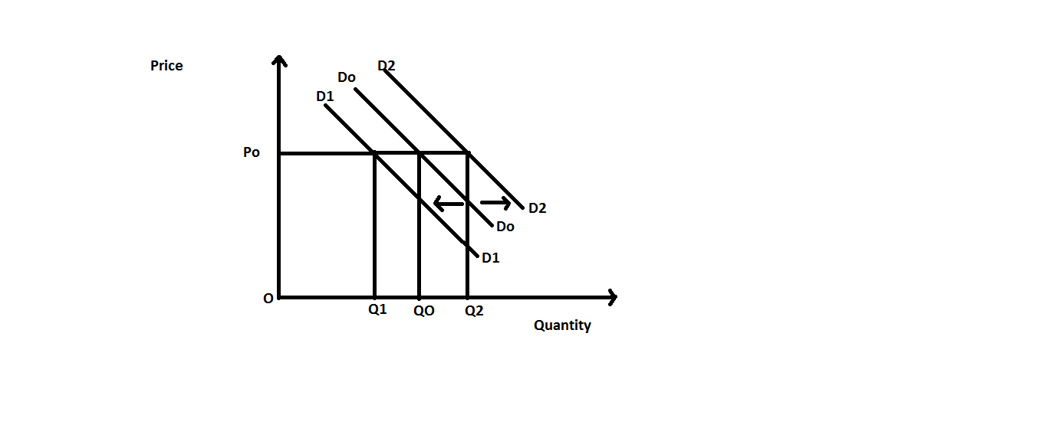

A shift in the demand curve from D_{O} to D₁ shows a decrease in demand from oq_{o} to oq₁ and a shift in the demand curve from D_{o} to D₂ shows an increase in demand from oq_{o} to oq₂. Change in demand is brought about by the following factors.
- A change in prices of substitute goods.
- A change in the prices of complementary goods.
- A change in tastes and preferences.
- A change in the levels of consumers income.
- Change in the level of advertising.
- Change in the population size and structure.
- Change in the level of credit provision.
- Change in the level of taxation and subsidization.
- Expectation of a change in the future prices.
- A change in seasons.
- Changes in the level of income distribution.
- Change in economic situation.
An increase in demand is a situation when at a constant price; more of a commodity is demanded due to factors affecting demand of that commodity becoming favourable.
It is illustrated by a shift in the demand curve to the right of the original curve.
(Diagram)
A decrease in demand is a situation when at a constant price, less of a commodity is demanded due to the factors affecting demand of that commodity becoming unfavourable. It is illustrated by a shift in the demand curve to the left of the original curve.
(Diagram)

Change in Quantity Demanded:
A change in quantity demanded refers to an increase or a decrease in the amount of a commodity demanded due to changes in the price of the commodity, other factors that affect demand of the commodity remaining constant. It involves movement along the same demand curve.
An increase in quantity demanded is brought about by a decrease in the price of a commodity and it is illustrated by a movement downwards along the same demand curve (Extension in demand).
A decrease in quantity demanded is brought about by an increase in the price of a commodity and it is illustrated by a movement upwards along the same demand curve (Contraction in demand).

Illustration of change in quantity demanded

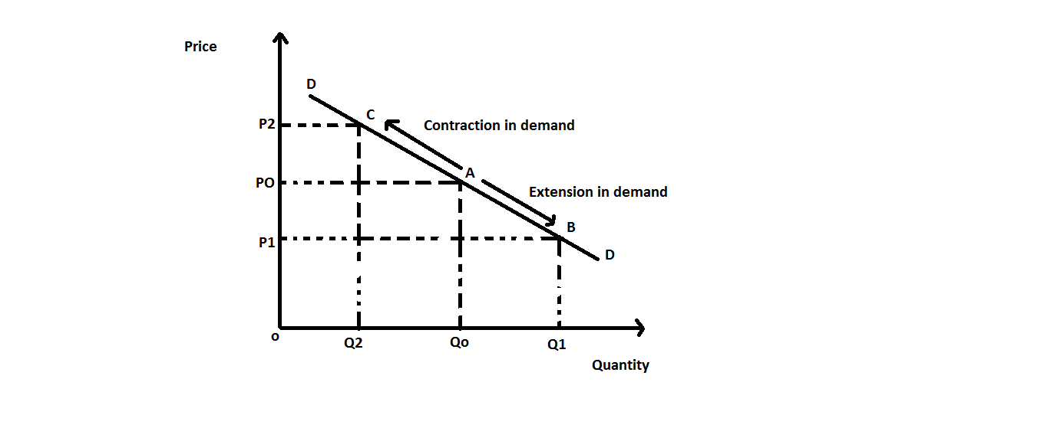
An increase in price from OP_{o} to OP₂ leads to a decrease in quantity demanded from OQ_{o} to OQ₂ while a decrease in price from OP_{o} to OP₁ leads to an increase in quantity demanded from OQ_{o} to OQ₁.
Distinguish between a change in demand and a change in quantity demanded. (2007-p.1)
Explain the factors that cause a change in demand for a commodity (2007-p.1)

N.B- Contraction in demand (decrease in quantity demanded) refers to a fall in the amount of a commodity demanded due to the increase in the price other factors affecting demand remaining constant.
(Diagram)
WHILE
Extension in demand (increase in quantity demanded) refers to a rise in the amount of a commodity demanded due to a decrease in the price of a commodity, other factors affecting demand being kept constant.
(Diagram)
Utility Analysis (Basis of Demand)
The behaviour of consumers is based on maximizing utility. Utility refers to the amount of satisfaction derived from the consumption of a given unit of a commodity. A commodity is therefore said to possess utility if it can provide satisfaction when consumed.
N.B: Utility does not necessarily mean usefulness, that is to say, a commodity may not be useful but it can provide satisfaction. Economists assume that utility is measurable and addictive. Utility is measured in units called utils.

Total Utility:
This refers to the total amount of satisfaction derived from the consumption of given units of a commodity. (Diagram)

Marginal Utility:
This refers to the additional satisfaction derived from the consumption of an extra unit of a commodity. It is expressed as a ratio of change in total utility to a change in quantity consumed ∆TU
∆QC
Diagram

A Hypothetical Utility Table
Quantity Consumed | Total Utility | Marginal Utility
0 | 0 | ---
1 | 20 | 20
2 | 35 | 15
3 | 45 | 10
4 | 50 | 5
5 | 50 | 0
6 | 45 | -5
7 | 35 | -10

The above information can be represented graphically:
(Relationship between Total Utility, Marginal Utility and Price)
(Diagram)

The following can be deduced from the table and graph above:
- Marginal utility equals total utility for the first unit consumed.
- When total utility is increasing, marginal utility is decreasing and price is also decreasing.
- When total utility is at maximum (bliss point, point of satiety, saturation point, point of maximum satisfaction), marginal utility is zero.
- When total utility is decreasing, marginal utility is negative. The extra units consumed give dissatisfaction or disutility to the consumer.

Distinguish between marginal utility of income and marginal rate of substitution (2005-p.1).
Marginal utility of income is the additional satisfaction derived from the expenditure of an additional unit of income.
WHILE
Marginal rate of substitution is the amount of one commodity a consumer could give up to obtain more units of another commodity while leaving the level of satisfaction unchanged.

The Law of Diminishing Marginal Utility:
It states that, as more and more units of a commodity are consumed, the extra satisfaction derived from consuming an additional unit of a commodity diminishes successively.
This law implies that, a consumer will buy more units of a commodity only when its price reduces. When fewer units are available, utility will be high and the consumer will be ready to pay a high price. This law explains the negative slope of the demand curve.

Assumptions of the Law of Diminishing Marginal Utility:
- It assumes constant tastes and preference.
- It assumes that the commodity consumed is divisible.
- It assumes that the commodity taken is the same/ homogeneous.
- It assumes that the commodity is consumed in reasonable amounts.
- Additional units of the commodity consumed should be continous and consumption of the commodity should not be spaced.
- Prices of the different units of substitutes to the commodity should remain the same because change of price affects rationality of the consumer.

Exceptions/Limitations/Criticism of the law of Diminishing Marginal Utility
- The law assumes that tastes and preference are constant, however in reality they keep on changing.
- The law does not apply in case of demand for money since the more money one gets, the more the satisfaction.
- The law does not apply in case of demand for knowledge or education. The more knowledge one acquires the more the satisfaction.
- The law does not apply for durable indivisible commodities because their use is spread over a period of time.
- The law does not apply when there is no continuity in consumption of a commodity, since the commodity consumed should be in succession at one particular time. That is to say, random consumption increases utility.
- The law is limited where commodities consumed are not the same. This is because each commodity consumed gives different satisfaction.
State the law of diminishing marginal utility.
What are the assumptions of the law of diminishing marginal utility?
What are the limitations to the law of diminishing marginal utility?

Consumer Surplus:
It refers to the difference between the price that the consumer is willing to pay for a commodity and what he actually pays. OR
It refers to the extra satisfaction a consumer enjoys without paying for it.
Consumer surplus is possible when a consumer finds that the market price is lower than what he was willing to pay for a commodity.
CS = T.U- FMP (M.U) X LAST UNIT OF A COMMODITY OR

CS = PLANNED EXPENDITURE- ACTUAL EXPENDITURE

EXAMPLE 1:
Quantity consumed | Total Utility
1 | 400
2 | 350
3 | 300
4 | 250
5 | 200
6 | 150

Assuming the market price is shs. 200 calculate the consumer surplus.
EXAMPLE 2

Quantity Consumed | Total Utility
1 | 300
2 | 250
3 | 200
4 | 150
5 | 100
6 | 50

Using shs. 150 as the fixed market price calculate the consumer surplus and illustrate it on a graph.

EXAMPLE 3
Study the table below showing the price and quantity purchased of commodity x and answer the questions that follow.
Price consumers are willing to pay (shs) | Units Purchased
30000 | 1
25000 | 2
20000 | 3
15000 | 4
10000 | 5
5000 | 6

- What is meant by consumers surplus? (01 mark)
- Calculate the consumers surplus if 4 units of the commodity were purchased at shs. 15000. (03 marks)
Consumer Surplus = PLANNED EXPENDITURE- ACTUAL EXPENDITURE

The relationship between consumer surplus and marginal utility is that, the higher the marginal utility, the higher the consumer surplus and the lower the marginal utility, the lower the consumer surplus.

The Slope of the Demand Curve:
A typical demand curve slopes from left to right downwards implying that, at a high price less is demanded than at a low price ceteris paribus. The slope of the demand curve is explained by the following factors.
- Price effect, this follows the first law of demand which states that, the higher the price the lower the quantity demanded and the lower the price the higher the quantity demanded keeping other factors constant. This is because at a higher price the commodity is less affordable and at a lower price the commodity is more affordable.
- Real income effect, real income refers to the purchasing power of money income. A fall in price of a commodity increases the consumers real income because he has to spend less in order to buy the same quantity. While a rise in price of the commodity reduces the consumers real income thus reducing the quantity demanded.
- Substitution effect, an increase in the price of a commodity relative to that of a substitute reduces the consumers demand for that commodity and instead increases the demand for the substitute. On the other hand, a decrease in the price of a commodity relative to that of a substitute increases the demand for that commodity and instead leads to a decrease in the demand for the substitute.
- The law of diminishing marginal utility, according to this law, where a consumer buys more units of a commodity, the marginal utility of that commodity declines continuously, meaning that a consumer buys more units of the commodity only when its price reduces. However, a consumer is willing to pay a high price for a commodity that gives him maximum satisfaction.
- The behaviour of low income earners, these buy more of a commodity when price reduces and buy less when the price increases. This is because they are very sensitive to price changes. The high income earners are not affected since they are capable of buying the same quantity even at a higher price.
- Number of uses of a commodity, a rise in the price of commodities with many uses forces consumers to use such goods for only vital purposes and their demand falls. However a fall in their price forces a consumer to use such commodities for various uses and their demand increases, e.g. an increase in electricity bill implies that the consumer uses for only vital purposes; however a decrease in the power bill forces a consumer to use the power for various purposes.

- Explain the law of demand (P.1 1996)
- Account for the negative slope of the demand curve
- Why is the demand curve downward sloping from left to right?
- Explain the inverse relationship between price and quantity demanded.
- Why may more of a commodity be demanded when its price reduces?

Abnormal/ Exceptional/ Regressive Demand Curves.
These are demand curves that violate the normal law of demand. These curves slope upwards from left to right implying that at a high price, more of a commodity is demanded and less is demanded at a low price. They occur under the following situations
- Demand for giffen goods, these are cheap foodstuffs whose demand increases with increase in price and decreases with a decrease in the price.
It should be noted that all giffen goods are inferior goods but not all inferior goods are giffen goods, this is because giffen goods are cheap food stuffs but not all inferior goods are giffen goods because not all inferior goods are basic cheap foodstuffs.
Demand curve of a giffen good

The demand curve is abnormal at low price levels, when the price is low at op₁, less quantity oq₁ is demanded and when the price is high at o p₂, more quantity oq₂ is demanded.
- Goods of ostentation, these are mainly demanded by high income earners to show status in society. More of such goods are demanded at a higher price than at a low price. The demand curve is regressive at high price level.
The demand curve for goods of ostentation:

At a low price op₁, less is demanded at oq₁ and at a high price op₂, more quantity oq₂ is demanded.
- Price expectation/speculation, when future prices are expected to increase, consumers generally buy more of a commodity even at high prices because of fear of further price increase. On the other hand, when future prices are expected to decrease, consumers may buy less even when the price is low.
Demand curve for speculative demand

Consumers continue to buy more of a commodity even at higher prices for fear of further price increase.
- Ignorance effect, consumers may buy more of a commodity even at a high price or less of a commodity even at a low price simply because they are not aware of the existing price or quality of a commodity.
- Habitual consumption, some people buy commodities even at high prices because such commodities are consumed out of habit or addiction. E.g. hard core smokers will buy cigarettes even at high prices.
- Effect of persuasive advertising, consumers may buy a commodity expensively simply because of persuasive advertising. On the other hand, less of a commodity may be bought despite low prices because of a dull advertisement.
- Bandwagon effect, some people may buy more of a commodity even at a high price or less of a commodity even at a low price because other consumers are doing so.
- Effect of an economic depression, this is a period of low economic activity characterized by low incomes, high unemployment, low prices etc. In such a situation, demand is low despite prices being low.
- Under what circumstances may the demand curve violate the law of demand?
- State any four reasons why a consumer buys less of a commodity when its price falls (2004-p.1)

Other Aspects of Demand: (inter-related demand)
- Joint or Complementary Demand, this refers to demand for commodities that are used together. An increase in demand for one leads to an increase in demand for the other. E.g. demand for cars and fuel.
- Competitive Demand, this refers to the demand for commodities that act as substitutes to one another. An increase in demand for one leads to a decrease in demand for the other e.g. demand for tea and coffee.
- Composite Demand (2011-p.2), this is the total demand for a good with many uses/ total demand for a good which can be used for more than one purpose. Examples of composite demand include
- The demand for electricity (for ironing, cooking, washing etc)
- The demand for timber (for construction, furniture making etc)
- The demand for wool (for cloth making, cushioning etc)
- The demand for water (for washing, cooking, irrigation etc)
- The demand for clay (for making pots, bricks, stoves etc)
- The demand for sugar (for baking, brewing, sweetening drinks etc)
- The demand for iron and steel (for construction, manufacturing etc)
- The demand for skins and hides (for making shoes, bags, belts)
- The demand for an axe (for splitting, cutting, tool of defence)
- The demand for cloth (for adornment, protection, warmth etc)
Qn.1. Give any two example of composite demand.
.
..
Qn.2. Give any two examples of commodities that have composite demand
- Derived Demand, this is demand for a commodity not for its own sake but for what it can produce e.g. demand for factors of production, demand for cotton is derived from the demand for cloth.
- Independent Demand, this refers to the demand for a commodity which is not influenced by the demand for other commodities.
- Market Demand, this is the total demand for a commodity in the market by different consumers at different prices in a given period of time. The market demand curve is derived from individual demand curves as shown below.
Market Demand Schedule:
Price | Consumer A | Consumer B | Consumer C | Market demand
500 | 10 | 12 | 13 | 35
1000 | 8 | 6 | 5 | 19
2000 | 4 | 5 | 4 | 13
3000 | 1 | 2 | 3 | 6

Diagrams:

The Concept of Elasticity:
This is the measure of the degree of responsiveness of a dependent variable (quantity demanded) to changes in an independent variable (price).

Elasticity of Demand: (2010-p.1)
Elasticity of demand is the measure of the degree of responsiveness of quantity demanded of a commodity due to changes in the factors that affect demand e.g. price of the commodity, income levels etc OR
Elasticity of demand is the ratio of change in demand of a commodity to change in the factors that affect demand.
The different categories of elasticity of demand include the following:
- Price elasticity of demand (PED)
- Income elasticity of demand (YED)
- Cross elasticity of demand (CED)

Price Elasticity of Demand:
This refers to the measure of the degree of responsiveness of quantity demanded of a commodity to changes in the price of that commodity. Price elasticity of demand is expressed as a percentage change in quantity demanded over a percentage change in price of a commodity. It is got using the formula below.
PED= (-) %age ∆ in quantity demanded
%age ∆ in price of the commodity
PED = (-) ∆Q X P
Q ∆P
OR
PED= (-) ∆Q X P
∆P Q
Where ∆Q means Q₂- Q₁
∆P means P₂- p₁
Q means original quantity demanded.
P means original price
Example one:
Calculate the price elasticity of demand when the price of a commodity falls from shs.10, 000 to shs 5,000 and the quantity demanded rises from 20 units to 40 units.
(Space)

Example two:
Assuming the price of a commodity increased from shs.1000 to shs1200 leading to a decline in quantity demanded from 12 units to 4 units. Calculate the price elasticity of demand.

Example three:
Study the table below and calculate the price elasticity of demand.
Year | Price (shs) | Quantity demanded
2010 | 800 | 20
2012 | 1000 | 15
Example 4: The price of a commodity increased by 30% and this led to a fall in quantity demanded of a commodity by 200kgs from 1000kgs. Calculate the appropriate elasticity of demand.
Interpretation of Price Elasticity of Demand:
Elastic demand (high). This is where a small change in price leads to a more than proportionate change in quantity demanded. The price elasticity of demand is greater than one but less than infinity, and the demand curve has a gentle slope as shown below.

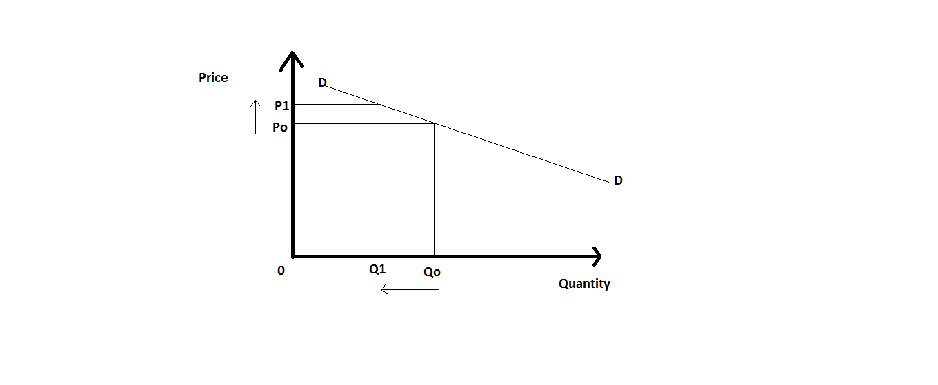
Inelastic demand (low). This is where a big change in price leads to a less than proportionate change in quantity demanded. The price elasticity of demand is greater than zero but less than one and the slope of the demand curve is very steep.
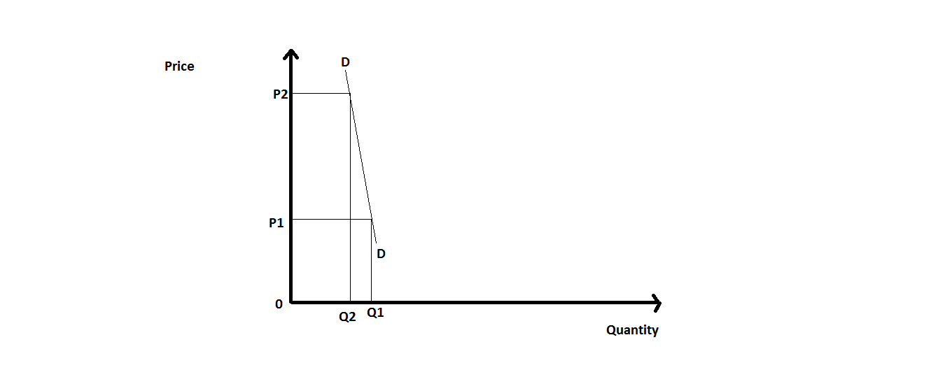
Unitary elasticity. This is where a change in price leads to an equal proportionate change in quantity demanded of a commodity. The price elasticity of demand is equal to one and the demand curve has a uniform slope.
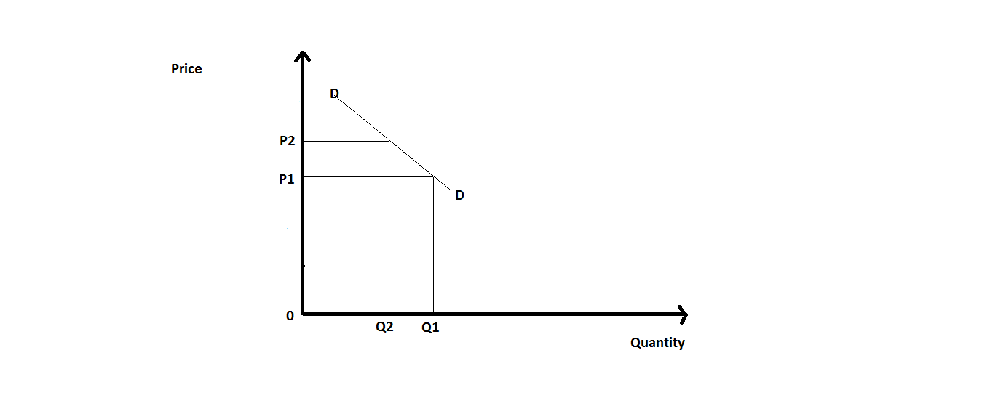
Perfectly inelastic demand. This is where a change in price has no effect on the quantity demanded. Price elasticity of demand is equal to zero and the demand curve is a vertical straight line.
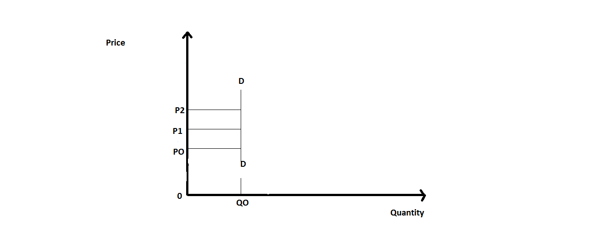
Perfectly elastic demand. This is where different quantities of a commodity are demanded at the same price. The price elasticity of demand is undefined or equal to infinity and the demand curve is a horizontal straight line.
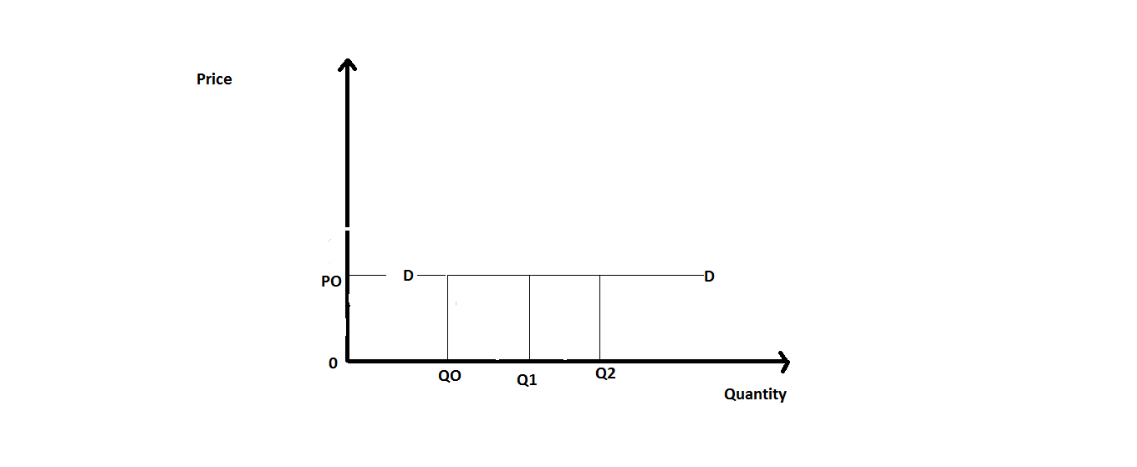
Factors determining price elasticity of demand:
Explain the factors that influence price elasticity of demand (2010-P.1-2005-p.1)
- Availability/ possibility of substitutes, commodities with close substitutes have elastic demand because a small change in price of one leads to a big change in demand of the other. This is because a consumer has alternatives. On the other hand, commodities without close substitutes have inelastic demand because a consumer has no alternative and he demands the same quantity whether the price is high or low.
- Availability of complements, these commodities are demanded jointly implying that, where the demand for the major complement is inelastic, then the demand for the other is also inelastic despite a big change in the price of the major commodity. However where the demand for the major commodity is elastic due to a small change in price, then the demand for the other commodity is also elastic. This is because these commodities are demanded together.
- Proportion of income spent on the commodity, commodities which take a small proportion of the consumers income have inelastic demand because the price change is not felt by the consumer, however commodities that take a big proportion of the consumers income have elastic demand since a slight change in the price is felt by the consumer.
- Level of income of the consumer, the high income earners have inelastic demand because they demand almost the same quantity whether the price is high or low. This is because they are less sensitive to price changes. On the other hand, low income earners have elastic demand because a small change in price of a commodity leads to a bigger proportionate change in quantity demanded. This is due to the fact that they are more sensitive to price changes.
- Degree of necessity of a commodity/nature of the commodity, necessities have inelastic demand because they are essential and the consumer buys almost the same quantity despite changes in the price. This is because the consumer cannot do without them. However, luxuries have elastic demand because they are not essential and a small change in their price leads to a bigger change in quantity demanded. This is due to the fact that a consumer can do without them.
- Level of addiction/habit in the use of the commodity, commodities that are habit forming are addictive and therefore have inelastic demand since a consumer buys almost the same quantity despite changes in the price. This is due to the fact that the consumer has a strong association with such commodities. However, commodities that are not addictive have elastic demand because a small change in the price leads to a bigger change in the quantity demanded. This is because the consumer has a weak association with such commodities
- Level of durability of the commodity/level of perishability of the commodity, durable commodities are long lasting and therefore they have inelastic demand reason being that the same quantity is demanded despite changes in the price especially to the consumer who has already bought the commodity. However, perishable commodities also have inelastic demand because the consumer buys the same quantity even when the price changes due to storage difficulties.
- Number of uses of a commodity, demand for goods that have several uses is elastic because a small change in their price forces a consumer to change the quantity demanded by a bigger proportion by using the commodity for only vital purposes while the demand for goods having a single use or few uses is inelastic since the consumer has no alternative and he buys almost the same quantity despite changes in the price.
- Time period- short run or long run, demand is inelastic in the short run because the consumer is not aware of the existence of cheaper substitutes while in the long run, demand is elastic since the substitutes are many and the consumer is aware.
- Possibility of postponement of demand for the commodity, commodities that can be postponed for future use have elastic demand since their use is not immediate while commodities that cannot easily be postponed have inelastic demand since their demand is urgent and immediate.
- Speculation about price changes, expectation of an increase in future prices leads to an increase in quantity demanded currently provided the current price does not exceed the expected price, this therefore leads to elastic demand. This is because the consumer would not prefer to buy fewer units in the future. On the other hand, expectation of a further fall in the future price leads to a decrease in the quantity demanded currently provided the current price does not go below the expected future price, this therefore leads to inelastic demand because the consumer would prefer buying more units of the commodity at a low price in the future.
- Seasonal changes, demand is inelastic for a commodity that is bought in the right season due to the increased attraction of the commodity to the consumer. However, inappropriate season for a commodity implies elastic demand because of the low level attraction of the commodity to the consumer.
- Level of awareness of availability of cheaper goods/ level of advertisement, demand is elastic where consumers are aware of the existence of cheaper substitutes due to increased awareness but where consumers are not aware of the existence of cheaper substitutes, they stick to demanding that commodity hence inelastic demand.
- Level of convenience of getting the commodity, demand is inelastic for a commodity that can be easily obtained however much the price changes; however commodities that are difficult to obtain have elastic demand reason being that a small change in their price leads to a bigger change in quantity demanded.

Assignment
Explain the factors that lead to inelastic demand for a commodity. OR
Account for low price elasticity of demand.

Practical Application of Price Elasticity of Demand/ Importance of PED:
To the consumers
- Price elasticity of demand is used by consumers in planning expenditures. Goods with inelastic demand tend to take a high proportion of consumers expenditure than products with elastic demand.
- It is used by consumers in bargaining, the consumers have a high bargaining power where the commodity has elastic demand due to the existence of close substitutes and the bargaining power is low where the commodity has inelastic demand.
To the producers
- It is used by producers in pricing goods and services so as to maximize profits. A producer charges a high price on goods with inelastic demand and a low price is charged on goods with elastic demand so as to maximize sales.
- Price elasticity of demand is useful to the producer (monopolist) in carrying out price discrimination. A monopolist charges a high price in a market with inelastic demand and a low price is charged in a market with elastic demand.
- It is used by producers in wage determination, where the demand for labour is elastic, strikes and other trade union tactics will not help much in raising wages, therefore such labour is paid low wages but where the demand for labour is inelastic, there is always fear of a strike, therefore such labour is paid a higher wage.
- It is used by producers in determining the tax incidence/ burden of paying tax, where the demand for a commodity is elastic, the producers bear a big tax burden because any attempt by them to change the price by a small proportion, there will be a bigger proportionate change in quantity demanded, however where the demand is inelastic, the consumer bears a bigger tax burden since quantity bought is almost the same despite changes in the price.
- Price elasticity of demand is used by producers to carry out sales promotion and advertisement. Sales promotion activities such as persuasive advertising are mainly applied to goods with elastic demand.
- Price elasticity of demand is used by producers in determining their revenue. Commodities with inelastic demand provide more revenue to the producers by charging high prices since consumers buy the same quantity despite price changes, however commodities with elastic demand provide less revenue at high prices since a small increase in price leads to a bigger decrease in quantity demanded.
To the Government:
- Price elasticity of demand is used by the government in providing subsidies to the industries. In most cases, subsidies are given to industries whose products have elastic demand in order to reduce competition by reducing their cost of production.
- It is used by the government to carry out its taxation policy in order to raise revenue. Where government wishes to raise more revenue from taxes, it must tax highly the commodities that have inelastic demand; this is because such commodities are demanded regardless of price changes.
- Price elasticity of demand is used by the government to determine which industries should be public utilities (state owned). Where the demand for the product is inelastic and it is essential to the public, the state usually takes over the production of such commodities in order to reduce consumer exploitation through charging high prices.
- It is used by the government to determine the tax incidence (burden of tax payment). Where the demand for the product is elastic, the producer pays more of a tax. Where the demand for the product is inelastic, the biggest tax burden is met by the consumer, where there is unitary elasticity, the tax burden is shared equally between the consumer and the producer, where demand is perfectly elastic, the tax burden is met by the producer alone and where demand is perfectly inelastic, the tax burden is met by the consumer alone.
- It is used by the government in redistributing income or achieving an equitable income distribution. This can be successful by taxing heavily commodities consumed by the rich (luxuries) and using such revenue to provide social services which can even benefit the poor.
- Price elasticity of demand is used by the government in price legislation. The government should fix a maximum price for commodities with inelastic demand in order to reduce consumer exploitation by the producers while government should fix a minimum price for goods with elastic demand in order to protect producers from consumer exploitation.
- It is used by the government to carry out the devaluation policy. It is a legal reduction in the value of the countrys currency in relation to other countries currency. This policy will be successful if the price elasticity of demand for both exports and imports of the devaluing country is elastic.
Explain the relevance/importance of price elasticity of demand to the government and producers.

Income Elasticity of Demand: (2009-p.2)
It refers to the measure of the degree of responsiveness of quantity demanded of a commodity due to changes in consumer’s income. It is expressed as a percentage change in quantity demanded over a percentage change in income of the consumer.

YED= %age ∆Q
%age ∆Y
YED =∆Q X Y OR YED= ∆Q X Y
Q ∆Y ∆Y Q

Example One:
Assuming a consumer increased his consumption for commodity x from 40 to 50 units as a result of an increase in his income from shs. 10,000 to shs. 20,000. Calculate the income elasticity of demand.

Example Two (2003-p.1)
Given that an individuals income increased from shs. 50,000 to shs. 80,000 per month and this led to an increase in the demand for a commodity by 10%; calculate the income elasticity of demand.

Example Three (1995-p.2)
Study figure 1 below showing the consumers level of income and the quantity demanded of good x and answer the questions which follow.
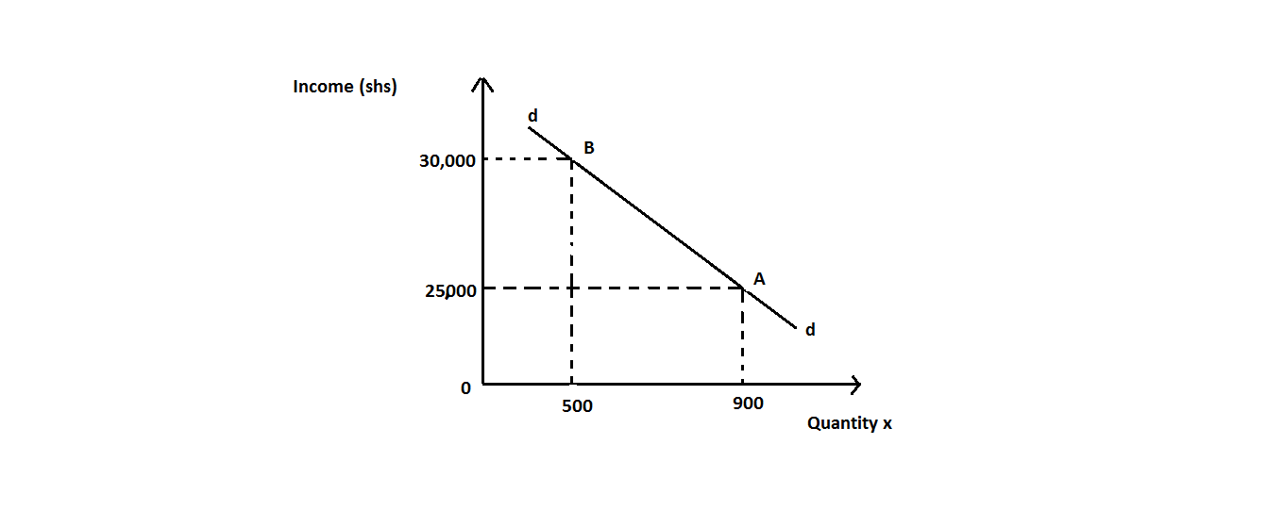
- Calculate the income elasticity of demand when the consumers income increases from A to B. (03 marks)
- What type of good is X? (01 mark)

Interpretation of Income Elasticity of Demand:
- When income elasticity of demand is positive, then the commodity in question is normal. This is because an increase in consumers income leads to an increase in quantity demanded.
- When income elasticity of demand is negative, then the commodity in question is inferior. This is because an increase in consumers income leads to a decrease in quantity demanded.
- When income elasticity of demand is zero, then the commodity in question is a necessity. This is because an increase in consumers income has no effect on the quantity demanded.

Uses of Income Elasticity of Demand (2009-p.2)
- It is used to determine the nature of goods i.e. inferior, normal or necessity.
- It is used by producers to forecast future demand as income changes.
- It used by the government in the taxation policy.

Cross Elasticity of Demand:
It is the measure of the degree of responsiveness of quantity demanded of a commodity (X) to changes in price of another related commodity (Y).
CED = % change in quantity demanded of commodity (X)
% change in price of commodity (Y)

CED = ∆Qd (x) X P (Y) OR ∆Q (X) X P (y)
∆P (Y) Qd (x) Q (x) ∆P(y)

Example one: (2007-p.2)
Calculate the cross elasticity of demand if the price of commodity X falls from Uganda shillings 2,000,000 to Ug. Sh. 1,600,000 per unit and the quantity demanded of commodity Y increases from 40,000 to 60,000 units. (03 marks)
State the relationship between commodities X and Y (01 mark)

Example two (2002-p.1):
Given that the price of a commodity Y decreased from Sh. 15,000 to shs 10,000 and the quantity demanded of a related commodity Z increased from 200,000kg to 600,000 kg, calculate the cross elasticity of demand for commodity Z. (02 marks)
State the relationship between commodities Y and Z (02 marks)

Example 3: (1999-p.2)
Calculate the cross elasticity of demand for commodity Y in the table below: (02 marks)
Year | Price of commodity X (in shs) | Quantity demanded of commodity Y (kg)
1998 | 12,000 | 300,000
1999 | 10,000 | 500,000

State the relationship between commodities X and Y. (02 marks)

Example four: (1994-p.1)
Calculate the relevant elasticity of demand if the price of commodity P increases by Ug. Shs. 800 per unit from Ug. Shs 1000 per unit and the quantity demanded of commodity Q increases by 50% per day. (03 marks)
How are commodities P and Q related? (01 mark)

The Supply Theory:
Supply refers to the quantity of a commodity producers are able and willing to put on the market at a given price in a given period of time.

The Law of Supply: (2008-p.1)
The law of supply states that, ceteris paribus, the higher the price, the higher the quantity supplied and the lower the price, the lower the quantity supplied.

Supply Schedule:
This is a table showing the quantity supplied of a commodity at various prices in a given period of time.

Price (shs) | Quantity supplied
200 | 2
800 | 4
1500 | 6
2000 | 8
2500 | 10

Supply Curve:
This is a locus of points showing different quantities of a commodity supplied at various prices in a given period of time. OR
It is a graphical representation of the supply schedule.

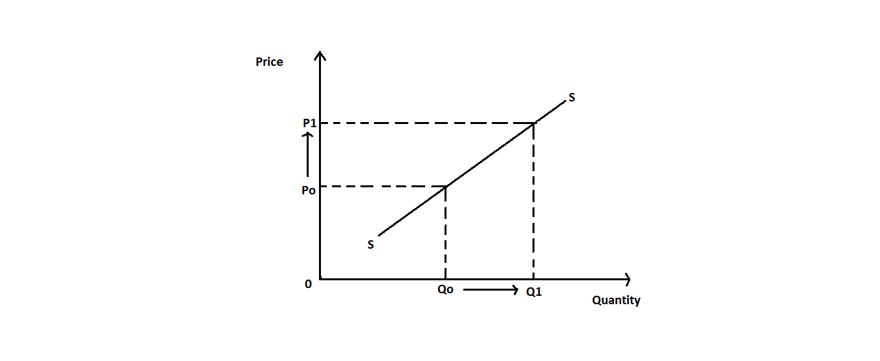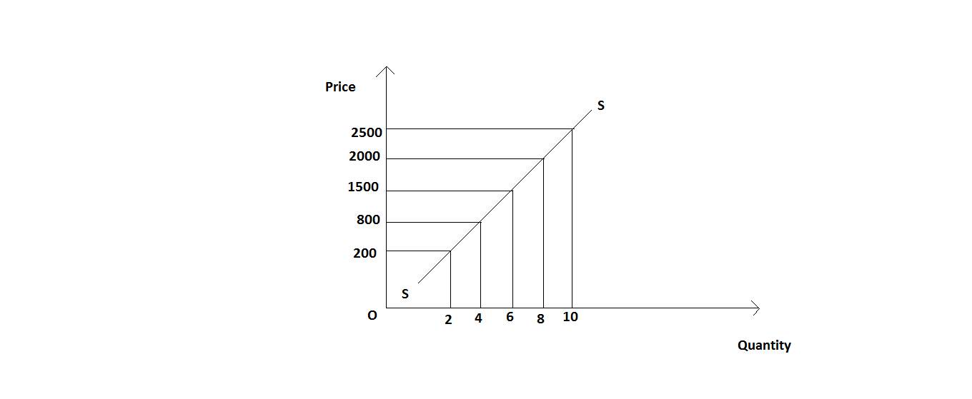

- The supply curve is upward sloping from left to right implying that at a high price, more is supplied and at a low price less is supplied.
- The supply curve is also upward sloping because of the profit motive. High prices lead to increased profits and therefore high supply while low prices lead to decreased profits and therefore low supply.

Market supply:
This is the total quantity of a commodity supplied by various producers in the market at different price levels in a given period of time. The market supply curve is therefore derived from individual supply curves as shown below.
Price (shs) | Supplier A | Supplier B | Supplier C | Market Supply
10000 | 2 | 1 | 3 | 6
15000 | 4 | 2 | 6 | 12
20000 | 6 | 3 | 9 | 18
25000 | 8 | 4 | 12 | 24
30000 | 10 | 5 | 15 | 30
Derivation of Market supply Curve:

Factors that affect supply:
Explain the factors that influence the quantity of a commodity supplied in an economy. (2006-p.1)
- Price of the commodity: other factors being constant, the higher the price, the greater the quantity supplied and the lower the price the smaller the quantity supplied. This is because at a higher price, the revenues from sales are high which implies high profits. However, at a low price, the revenues from sales are low which implies low profits.
- Price of substitutes, a fall in price of a substitute (tables) results into increased supply of the other product in question (chairs) because production of the commodity in question is more profitable while a rise in price of a substitute leads to a reduction in supply of the other commodity in question because production of the commodity in question is less profitable.
- Price of complements, a rise in the price of a complement (beef) leads to an increase in supply of the commodity in question (hides) and a fall in price of complements leads to a decrease in supply of the commodity in question. This is because the two commodities are supplied together.

- The level of demand for the product, the higher the demand for a commodity, the more the producers are motivated due to high profits earned from increased sales. This leads to greater the output hence the higher the supply. However, where there is low the demand for a commodity, producers are demotivated due to small profits earned from low sales and this leads to lower the output thus the lower the supply.
- Number of producers, an increase in the number of producers leads to increase in competition which propels producers to aggressively search for more market thus leading to an increase in supply and a decrease in the number of producers leads to a fall in competition and this makes producers relax to aggressively look for market thus a decrease in output and supply.
- The gestation period, a long gestation period makes it difficult to increase production in the short run which leads to a reduction in output and supply; however a short gestation period makes it possible to increase production in case of need to increase supply. This leads to an increase in output and supply.
- The level of technology, use of better production methods implies greater efficiency and this reduces cost of production thus leading to increase in supply, however inefficient production methods increase the cost of production hence reducing supply.
- Natural factors, favourable natural factors such as reliable rainfall stimulate production of especially agricultural products and this leads to increase in supply. However unfavourable natural factors such as low rainfall discourage production and this leads to a decrease in supply.
- Working conditions, favourable working conditions motivate labour and this stimulates production thus leading to greater output and hence increased supply, while poor working conditions demotivates and discourages labour hence leading to a decrease in supply.
- Government policy of taxation and subsidization, favourable government policies such as low taxes on producers and provision of subsidies reduce the cost of doing business and this encourages production thus leading to increased supply. However, unfavourable policies such as high taxes on producers and absence of subsidies increase the cost of doing business and this discourages production which leads to a decrease in supply.
- Cost of factors of production, the lower the cost of factors of production, the higher is the ability of the producer to hire more factor inputs. This leads to high production, output thus high supply. However, a higher cost of factors of production limits the producers to hire more factor inputs which leads to less production, output and supply.
- Degree of freedom of entry of firms in production, free entry of firms in production encourages penetration of new firms into business and this increases the number of producers, output and supply, while restricted entry of firms into production discourages new firms into penetrate into business and this reduces the number of producers. This leads to a decrease in output and supply.
- Goals and objectives of the firm, a firm whose goal is profit maximization always restricts output in order to sell at higher prices hence leading to a decrease in supply while a firm whose aim is maximizing sales and increasing welfare, produces more output thus increasing supply.
- Level of infrastructural development, where means of transport and communication facilities are adequate and well developed, the cost of production reduces and this enables distribution of commodities from one place to another and this increases supply. Poorly developed distribution channels inform of poor roads discourage production due to increased cost of production thus leading to a decrease in supply.
- Expectation of future price changes, where the future commodity price is expected to fall, supply increases currently to avoid selling for lower profits because of lower price in future and where the future commodity price is expected to increase, supply decreases currently because it is more profitable to increase supply and sell in the future.
- Political climate, a peaceful and stable political climate increases supply because stable production is encouraged. This is because producers are assured safety to their lives and property. However, political instability discourages production due to disruption created by low safety of the live and property of producers hence leading to a decrease in supply.

(Shifts in Supply) Change in Supply and Change in Quantity Supplied:
Change in Supply:
This refers to an increase or decrease in the amount of a commodity supplied at a constant price due to changes in other factors affecting supply.
An increase in supply is indicated by the shift of the supply curve to the right while a decrease in supply is indicated by the shift of the supply curve to the left as shown below.

The shift of the supply curve from so-so to s₂-s₂ shows an increase in supply from q_{o}-q₂ at a constant price P while a shift of the supply curve from so-so to s₁-s₁ shows a decrease in supply from q_{o}-q₁.

Question: Explain the factors that influence a change in supply.
a) Distinguish between joint supply and competitive supply (2012)
b) Explain the conditions that may lead to a decrease in supply of a commodity in your country (2012 p2)
- Decline in price of a jointly supplied product
- Increase in the price of a competitively supplied product
- Natural conditions becoming unfavourable
- Change in producers objective from sales maximization to profit maximization.
- The political atmosphere becoming unfavourable
- Break down of infrastructure
- Decline in the number of producers
- Increase in the cost of production
- Decrease in demand
- Government policy on production of a commodity becoming unfavourable
- Expectation of future price increase
- Decrease in the supply of factors of production
- Fall in the efficiency of factors of production
- Shift from capital intensive to labour intensive technology
- Depreciation of capital /machines.

Change in Quantity Supplied:
It refers to an increase or decrease in the amount of a commodity supplied due to changes in the price of a commodity when other factors affecting supply are constant.
An increase in quantity supplied (extension in supply) is brought about by an increase in price of the commodity while a decrease in quantity supplied (contraction in supply) is brought about by a decrease in the price of the commodity as shown below.

An increase in the price of the commodity from p_{o}-p₂ leads to an increase in the quantity supplied from q_{o}-q₂ while a decrease in the price of a commodity from p_{o}-p₁ leads to a decrease in quantity supplied from q_{o}-q₁.

QUESTION: (2009-p.1)
Distinguish between an increase in supply and an increase in quantity supplied of a commodity (04 marks)
An increase in supply is a situation when at a constant price; more of a commodity is put on the market due to favourable factors affecting supply.
It is illustrated by a shift in the supply curve to the right of the original curve.

INCREASE IN SUPPLY
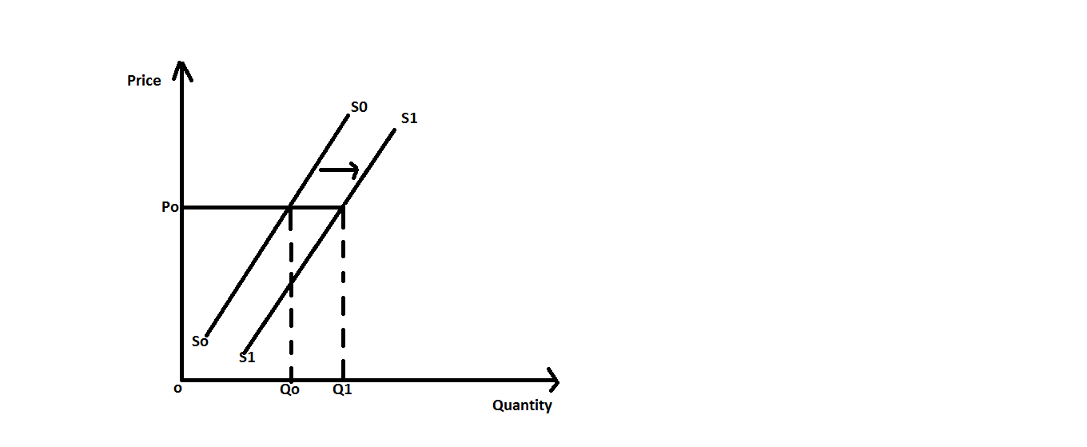
WHILE
An increase in quantity supplied is a situation when the amount of a commodity supplied rises due to a rise in the price of the commodity other factors affecting supply of that commodity held constant.

It is illustrated by an upward movement along the same supply curve.

INCREASE IN QUANTITY SUPPLIED
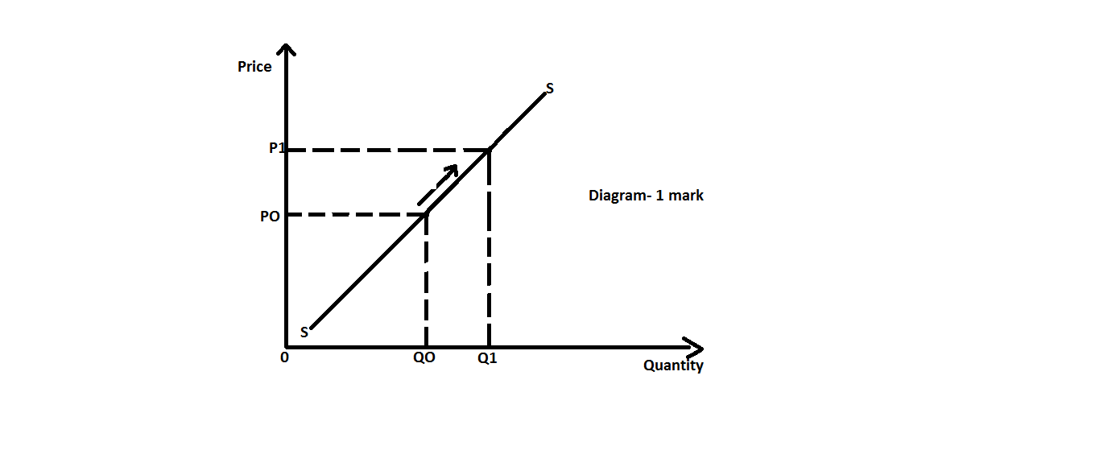
An increase in price from p_{o} to p₁ leads to increase in quantity supplied from q_{o} to q_{1.}

Explain the factors that lead to an increase in supply of a commodity. (16 marks)
- Improvement in the state of technology
- A decrease in the costs of production
- Natural factors becoming favourable in case of agricultural products.
- Government policy on production of a commodity becoming favourable e.g. increased subsidization/reduced taxation.
- Political climate becoming favourable
- Increase in the number of producers/Freedom of entry of firms.
- Increase in prices of complementary goods
- A fall in prices of substitutes in production
- Increase in the availability of factors of production/resources
- Increase in the demand for the commodity/Expansion of the market.
- Change in the producers objective from profit maximization to sales revenue maximization.
- Expected fall in price of the commodity in future
- Improvement in infrastructure/ Distribution system
- Shift from labour intensive to capital intensive technology.

Abnormal/Regressive/Exceptional supply Curves:
These are supply curves that violate the law of supply. They occur under the following situations.
- Fixed supply: This is where quantity supplied does not change despite a change in the price. The notable examples include supply of land, supply of agricultural commodities with a long gestation period.
Diagram
- Backward bending supply curve of labour: The supply curve for labour is regressive in that further increase in wages leads to a decrease in the working hours. As labour is paid more wages, it reaches a certain point beyond which the working hours reduce and this is due to:
- Presence of target workers.
- Natural limitations such as old age, poor health, laziness etc.
- Presence of progressive taxation.
- Preference for leisure.
- Poor working conditions.
- Political instability
(Diag)
Why is the labour supply curve backward bending?
- Speculation of price changes: Where producers expect prices to reduce in the future, they may supply more even at relatively low prices currently, however where prices are expected to increase further in the future, current supply may not increase much even at high prices.
- Dumping: This is where more of a commodity is sold at a low price in another country basically with the aim of disposing of surplus output.
- Ignorance of producers about the prevailing market conditions such as demand. This results into supply not increasing with increase in price.

Other Aspects of Supply:
- Joint/ complementary supply: (2012-p.2) this refers to the supply of two or more commodities from the same process of production such that an increase in the supply of one commodity leads to increase in the supply of the other. E.g. beef and hides from animals, petrol, diesel and paraffin from crude oil, mutton and wool from Sheep etc.
- Composite supply: This refers to the total supply of commodities which act as substitutes to one another. Examples include the supply of beef, chicken and pork, the supply of tea, coffee, and cocoa, the supply of blue band, butter and jam.
- Competitive supply: (2012-p.2) this refers to the supply of two or more commodities that use the same resources for their production such that an increase in the supply of one commodity leads to a decline in the supply of the other for example eggs and chicken, milk and meat from cows, crop and animal production from a piece of land.

Producer Surplus: (2013-p.1)
This refers to the excess earnings between what the producer was willing to charge for the commodity and what he actually receives after selling it. The producer surplus therefore is the excess earnings of a producer over and above the average cost of production.
The producer surplus is determined by the market price. The higher the market price, the higher the producer surplus and the lower the market price, the lower the producer surplus.
Producers surplus=Actual revenue-Expected revenue

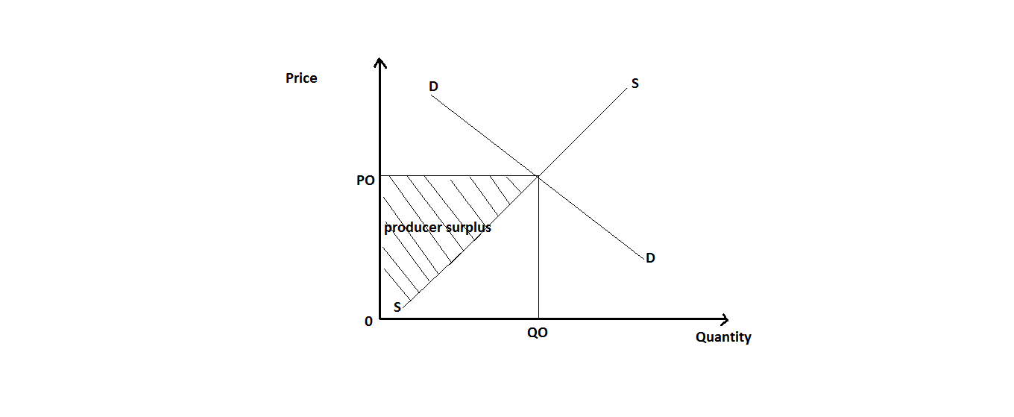
Elasticity of Supply:
This refers to the measure of the degree of responsiveness of quantity supplied of a commodity due to changes in any of the determinants of supply.

Price Elasticity of Supply:
It refers to the measure of the degree of responsiveness of quantity supplied of a commodity due to changes in the price of a commodity.

PES= % change in quantity supplied
% change in price of a commodity

PES = ∆Qs X P OR ∆Qs X P
∆P Q Qs ∆P
Example one:
Calculate the price elasticity of supply assuming the quantity supplied of a commodity falls from 60 to 40 units and price falls from shs. 8,000 to 4,000 per unit.

Example two: (1994-p.2)
The price of sugar increased from Ug.Shs 800 per kilogram to Ug.Shs 1200 per kilogram. The quantity of sugar supplied in the market increased from 2,000 tons to 5,000 tons.
- Calculate the price elasticity of supply for sugar. (02 marks)
- Giving reasons, briefly state whether supply is elastic or inelastic. (02 marks)

Example three: (2006-p.1)
Study the supply schedule below and answer the questions which follow.
 | A | B | C | D
Price of maize in Shs/kg | 10 | 20 | 30 | 40
Quantity of maize supplied in kg. | 50 | 100 | 150 | 200

- Draw a supply curve using the information in the schedule. (02 marks)
- Calculate the price elasticity of supply for the commodity from point A to D (02 marks)

Interpretation of Price Elasticity of Supply:
- Elastic supply: This is where a small percentage change in price leads to a bigger percentage change in quantity supplied. Price elasticity of supply is greater than one but less than infinity and the supply curve has a gentle slope as shown below.
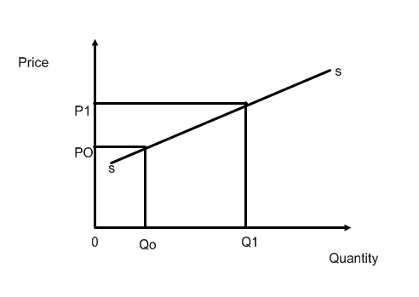
- Inelastic supply: This is where a big percentage change in price leads to a less than proportionate change in quantity supplied. Price elasticity of supply is greater than zero but less than one and the supply curve has a steep slope as shown below.

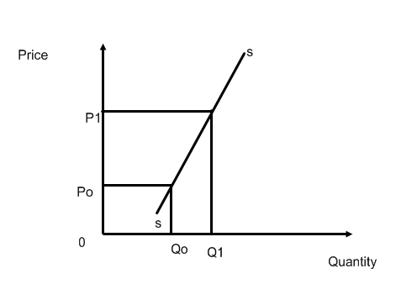

- Unitary elasticity of supply: This is when a percentage change in price is exactly proportional to the percentage change in quantity supplied. Price elasticity of supply is equal to one and the supply curve has a normal slope as shown below.
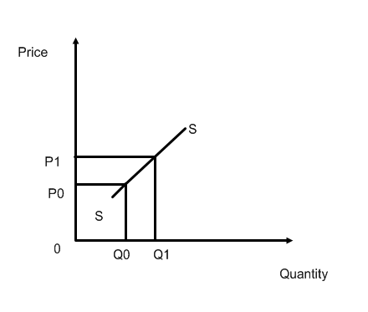
- Perfectly inelastic supply: This is when a change in price has no effect on the quantity supplied. Price elasticity of supply is zero and the supply curve is vertical as shown below.
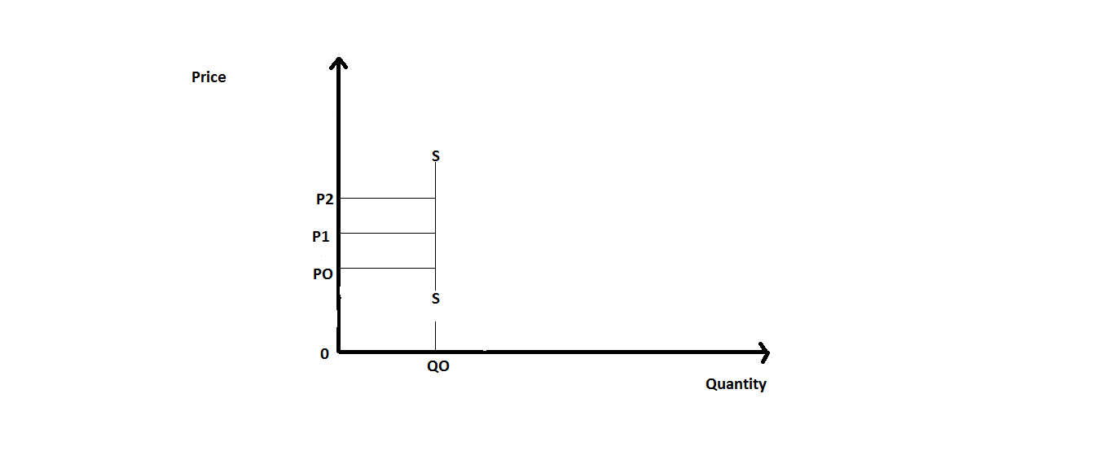

- Perfectly elastic supply: This is when various quantities of a commodity are supplied at a constant price. Price elasticity of supply is equal to infinity and the supply curve is horizontal as shown below.

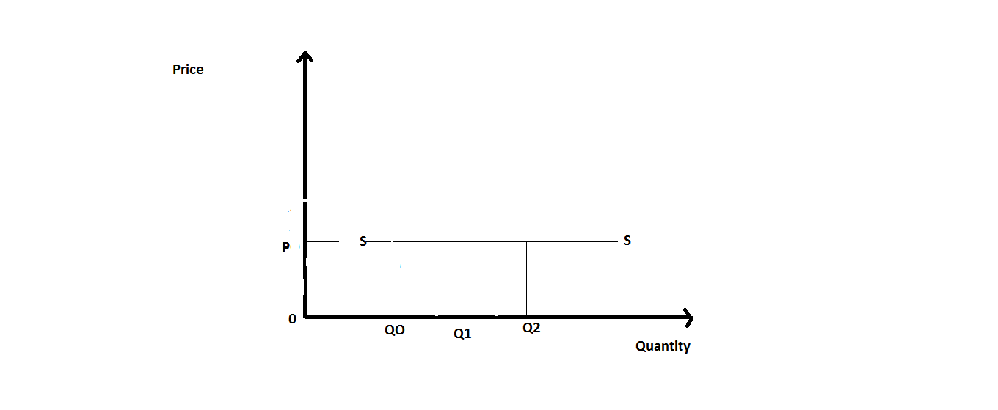
Factors that determine elasticity of supply/Price elasticity of supply:
- Gestation period/length of production process, Commodities with a long gestation period such as agricultural commodities have inelastic supply because their supply takes long to respond to changes in price. However, commodities with short gestation period have elastic supply because their supply easily responds to changes in the price.
- Ease of entry of new firms into the industry, free entry of new firms into production leads to elastic supply due to increased production of goods because firms are many while restricted entry of new firms into production leads to inelastic supply since few firms can not easily produce enough output to respond to changes in price.
- Natural factors, favourable natural factors such as high rainfall lead to elastic supply of especially agricultural products since they provide conducive conditions for their production, however, unfavourable natural factors such as low rainfall lead to inelastic supply of especially agricultural commodities since they discourage production of such commodities.
- Nature of the product, durable commodities have elastic supply since they can be stored for a long period of time such that they are supplied when their prices increase. However, perishable commodities have inelastic supply because they cannot be stored for long implying that they cannot be immediately supplied when prices increase.
- Level of technology, products that are produced with the help of simple and cheap technology have elastic supply because they can easily be produced and supplied when their prices rise, however, products that are produced using complicated technology have inelastic supply because it is difficult to produce them and increase their supply as price increases.
- Cost of factors of production and their availability, cheap and readily available factors of production lead to elastic supply since producers can adequately acquire them and increase supply as price increases while scarce and expensive factors of production make supply to be inelastic because producers find it difficult to hire enough of them to increase supply incase price increases.
- Level of taxation and subsidization, supply is elastic where the government charges low taxes on producers and where it provides subsidies to them. This is because the cost of production is reduced to support production. However, high taxes and low subsidies on producers make supply to be inelastic because the cost of production is increased and this discourages production.
- Time period, supply is inelastic in the short run period because producers are not able to vary technology and factors of production; however, in the long run, supply is elastic since technology and factors of production can easily be varied to produce more output.
- Availability of excess capacity, supply is elastic where a firm is operating at excess capacity because the firm has the resources to expand its production capacity. However, supply is inelastic where firm is operating at full capacity because the firm does not have the resources to expand its production capacity since all resources are fully utilized.
- Availability of transport, supply is elastic where transport is developed and efficient since commodities can easily be taken to the market whenever the price increases. However, under developed and inefficient transport leads to inelastic supply because commodities can not easily be transported to the market whenever the price increases.
- Number of producers, supply is elastic where there are many producers since an increase in price forces producers to increase supply due to competition but where producers are few, supply is inelastic because quantity supplied cannot be easily increased with increase in price since the competition is low.
- Expectation of future price changes, supply is elastic currently when the future price is expected to decrease since producers would not prefer to supply more in future when the price is decreased because they would get low profits; however, supply is inelastic currently when the future price is expected to increase since producers would prefer to supply more in the future in order to get more profits.
- Political climate, stable political climate leads to increase in supply thus elastic supply. This is because producers are less disrupted since they have safety to their lives and property, but political instability disrupts production because producers do not have assurance to the safety of their lives and property thus leading to inelastic supply.

Question:
Distinguish between price elasticity of supply and elasticity of supply.
Explain the factors that lead to elastic supply for a commodity.

Importance of price elasticity of supply:
- It is used in explaining price fluctuations in the agricultural sector, and this is due to the inelastic supply of agricultural products.
- It is used by the government in adopting policies to increase the supply of a commodity such as imposing low taxes on producers, improving infrastructure etc.
- It guides government in her taxation policy. Taxes imposed on producers can bring more revenue when supply is inelastic.
- It determines revenue for the producer, where supply is elastic, a producer gains more revenue by increasing the supply.

Cross elasticity of supply:
It refers to the measure of the degree of responsiveness of quantity supplied of a commodity due to changes in the price of another related commodity.

CES = ∆Qs X P OR %age ∆Qs
∆P Qs %age ∆P

EXAMPLE ONE:
Assuming the price of commodity P increased from shs. 2500 to shs 3000 and this led to an increase in quantity supplied of commodity Q from 10 to 20 units. Calculate the cross elasticity of supply and state examples of the two commodities and their relationship.

EXAMPLE TWO:
Assuming that at one time, the price of commodity X was shs. 1500 and the quantity supplied of commodity Y was 20 kg. If the price of commodity X decreased to shs. 1300 and the quantity supplied of commodity Y increased to 25 kg. Calculate the relevant elasticity of supply and state the relationship between commodities X and Y.

Effect of a change in demand and supply on equilibrium price and quantity:
When there is a change in demand and supply, the equilibrium price and quantity also tends to change as shown below.
- An increase in demand with constant supply

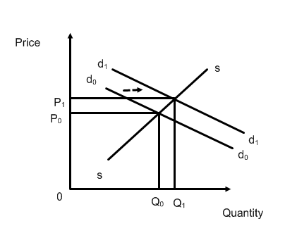
Effects
Equilibrium price increases from P_{o} to P₁
Quantity demanded increases from Q_{o} to Q₁

- A decrease in demand with constant supply

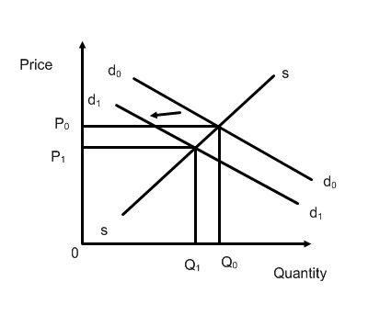
Effects
Equilibrium price decreases from p₀ to p₁
Equilibrium quantity demanded decreases from Q₀ to Q₁

- An increase in supply with constant demand

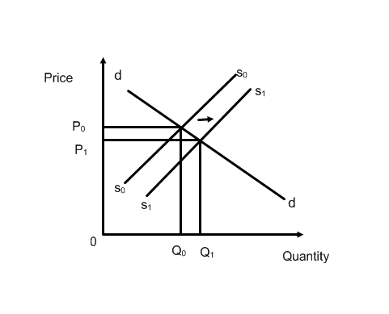
Effects
Equilibrium price decreases from Po to P₁
Quantity supplied increases from Qo to Q₁

- A decrease in supply with constant demand

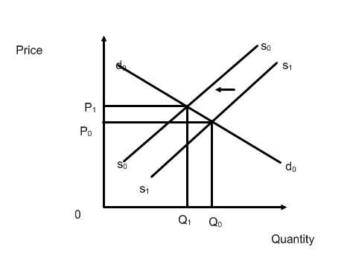
Effects
Equilibrium price increases from P₀ to P₁
Quantity supplied decreases from Q₀ to Q₁.

- An equal increase in both demand and supply Effects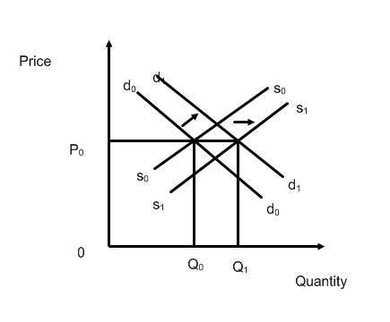
Equilibrium price remains constant at P_{o}
Quantity demanded and supplied increase from Q₀ to Q₁
- An equal decrease in both demand and supply
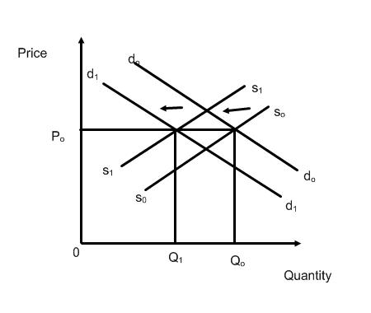

Effects
Equilibrium price remains constant at P_{o}
Quantity supplied and demanded decrease from Q_{o} to Q₁

Concept of Equilibrium:
Equilibrium is a state of balance where economic forces have no tendency to change. Equilibrium may take the following, equilibrium price, equilibrium income, equilibrium quantity demanded and supplied, etc.
Disequilibrium is a state of imbalance where economic forces are not showing the tendency of striking a balance.
Question:
Given the following demand and supply functions, determine the equilibrium price, equilibrium quantity demanded and supplied
Qd= 36-4p
Qs= -12+12p

The market concept:
In economics, a market is an arrangement through which buyers and sellers come together to exchange goods and services. OR It refers to any place where buyers and sellers meet to negotiate terms of exchange of goods and services.
N.B: Markets exist in space and time.

Features of a market:
A market should have;
- Participants (buyers and sellers).
- Commodities to be exchanged.
- Price at which commodities are to be exchanged.
- The medium of exchange.

Types of Markets:
- Factor market, it is one where factors of production are exchanged e.g. capital, land, labour etc.
- Product/commodity market, it is one where goods and services are exchanged.
- Spot market, it is one where goods and services are exchanged immediately once the price is agreed.
- Future market, it is one where buyers and sellers agree on the price of a commodity which is to be sold in the future.
- Perfect market, it is one where there are many buyers and sellers producing similar/homogeneous commodities.
- Imperfect market, it is one where there is a lot of competition among firms, there is imperfect knowledge about market conditions and there is no free mobility of factors of production.
- Black market, it is one where goods are sold and bought at higher prices than the legal maximum price set by the government.
Causes of a black market:
- Scarcity of commodities
- Excessive demand for goods.
- Fixing of a maximum price by government.
h. Stock exchange (2006-p.2): it is a market where already issued securities (such as shares) are bought and sold/ exchanged.
Functions of stock exchange in Uganda (2006-p.2)
- It publishes useful information about listed companies.
- It monitors the performance of listed companies.
- It encourages long term investment.
- It regulates the price of listed securities.

Companies listed on the Uganda securities exchange.
- Uganda clays limited
- Kenya airways
- Jubilee holdings limited
- British American tobacco limited
- Development finance company of Uganda (DFCU BANK)
- New vision publishing and printing company
- Stanbic Bank limited
- Kenya commercial bank
- Equity Bank limited
- Bank of Baroda limited
- National Insurance Corporation
- Centum investment
- Nation media group
- East African Breweries limited
- Umeme

- Money market (2009-p.2), it is one where short term financial assets/securities are exchanged.
Characteristics of money markets in developing countries (2007-p.2):
- They are mainly urban based.
- They have few participants.
- They mainly charge high interest rates.
- They mainly operate on a small scale.
- They deal in limited variety of financial assets.

- Capital market (2009-p.2), it is one where long term financial securities are traded.
Functions of capital markets in Uganda: (2009-p.2)
- They mobilize savings.
- They encourage investment.
- They regulate the price of financial assets.
- They promote ease of convertibility of assets e.g. from near cash to cash.

Price mechanism:
Questions.
- What is meant by the term price mechanism? (2003-p.1)
- Explain the role of price mechanism in the allocation of resources in an economy. (2003-p.1)
- Examine the role of price mechanism in an economy (2004-p.2)
- What are the limitations of the price mechanism in allocating resources? (2004-p.2)
- Explain the role of price mechanism in resource allocation. (2011-p.1)
- Examine the implications of price mechanism in an economy. (2011-p.1)
- Explain the defects of price mechanism in an economy.
- How can the defects of price mechanism be controlled?
- Why may the government interfere with the operation of price mechanism?
Price Mechanism:
It is a system in a free enterprise economy where prices are determined by the market forces of demand and supply.
Assumptions of Price Mechanism:
- There is limited or no government intervention.
- There is existence of consumer sovereignty.
- The aim of production is for profits and producers produce goods whose prices and profits are high.
- Consumers aim at maximizing utility by buying from the cheapest source.
- Prices of goods and services are determined by forces of demand and supply.
- There is free mobility of factors of production in between different uses and geographical locations.
- There is free entry of new firms into production and free exit of firms out of production.
Role of price mechanism in resource allocation. (2011-p.1)
- It enables the efficient allocation of resources by determining what to produce. A producer always allocates resources to produce a commodity whose price is high.
- It determines when to produce. Producers who aim at profit maximization produce when demand is high.
- It determines where to produce/ location of production unit. Producers normally set up production units in areas that are profitable.
- It determines the type of technology to be used in production/ how to produce. Where machines are expensive, human labour is used.
- Price mechanism determines the distribution of goods and services i.e. for whom to produce. Producers produce only those commodities which are demanded for basing on consumer sovereignty.
- It provides an automatic adjustment between demand and supply/ how much to produce. Due to existence of consumer sovereignty, producers only produce commodities demanded for, thereby minimizing resource wastage.
- It provides an incentive for economic growth, in cases where high prices, it encourages high production.
- It determines income distribution. This implies that income goes to those with more economic resources inform of factor prices such as wages, rent, interest and profits.
- It guides consumers when making choice, since consumers aim at maximizing utility; they normally buy from the cheapest source since there are many sellers.
Role of price mechanism/implication of price mechanism (2011-p.1)
Positive implications/role:
- It encourages competition which leads to production of better quality goods and services.
- It encourages arbitrage which benefits producers. It refers to the buying of goods where they are abundant and cheap and taking them to an area where there is a shortage and the price is high in order to maximize profits.
- It increases employment opportunities due to the free entry of firms in production/ due to presence of many firms in production.
- It avails a wide variety of goods and services, since there are many producers and this widens consumer choice.
- It promotes efficient allocation and utilization of resources due to the desire to maximize profits. This in turn increases production hence economic growth.
- It promotes incentive for hard work because of personal initiative, and this leads to increased production.
- It reduces the costs of administration because of limited government control.
- The profit motive encourages research, invention and innovations. This leads to expansion of production units and production of better quality goods.
- It decentralizes economic powers in that individual households make their own decisions due to consumer sovereignty.
- Price mechanism encourages speculation i.e. buying and storing commodities during periods when there are in abundant supply and cheap to be sold later at a high price during periods when they are scarce in order to maximize profits.
Negative implications/role of price mechanism (2011-p.1)
- It encourages consumer exploitation through charging high prices.
- It distorts consumer choices through persuasive advertising.
- It causes unemployment when inefficient firms are out competed and pushed out of the production process. This causes laying off of labour.
- It worsens income and wealth inequality in the economy due to the private ownership of resources and the freedom given to private individuals to accumulate wealth.
- It fails to allocate resources in priority areas/ignores public utilities which are essential but unprofitable because the aim of producers is profit maximization.
- It causes divergence between private and social benefits for example over exploitation of resources in a bid to maximize profits.
- It creates monopoly power when inefficient firms are pushed out of production. This increases consumer exploitation inform of being charged high prices.
- It worsens economic instabilities in an economy in form of price fluctuations because of the desire to maximize profits.
- It causes wastage of resources due to wasteful competition that even results in duplication of activities.
- It does not adjust quickly to structural changes since private producers aim at maximizing profits.
- It encourages production of demerit goods which are dangerous to the health of consumers because of the desire to maximize profits.

How can the defects of price mechanism be reduced?
- Through the use of a progressive taxation system, where the rich are taxed more than the poor in order to control income inequality.
- Through setting a maximum price in order to reduce consumer exploitation by profit oriented producers.
- Encouraging the formation of consumer associations to sensitize consumers about market prices and the quality of commodities.
- Legislating anti-monopoly laws with an aim of controlling monopoly power in order to reduce consumer exploitation.
- The government can subsidize the poor and disadvantaged groups by providing them with affordable essential commodities which are not provided under price mechanism.
- The government can provide licenses or permits to private individuals in order to control over exploitation of resources. The government should also set up laws governing resource exploitation.
- The government can nationalize private monopoly firms in order to reduce their power and control exploitation of consumers in form of being charged high prices.
- The government can interfere by providing public goods such as roads, defense which are not provided under price mechanism because they are unprofitable.
- The government can subsidize the inefficient firms that are incurring losses in order to reduce unemployment which arises when they are pushed out of production.
- The government can control production of demerit goods by banning their production and it can set up institutions to check on the quality of goods.
Why should the government interfere with price mechanism?
Why should the government undercut consumer sovereignty?

The government should interfere with price mechanism in order:
- To reduce consumer exploitation by producers through setting up a maximum price.
- To control income inequality by adopting a progressive taxation system, where the rich are taxed more than the poor.
- To reduce monopoly power by nationalizing private monopoly firms and setting up anti monopoly laws that prevent emergence of monopoly.
- To reduce unemployment by subsidizing the weak inefficient firms to enable them remain in production.
- To control over exploitation of resources by issuing licenses to private producers and also imposing fines to the offenders.
- To provide public goods such as roads which are not provided under price mechanism because of being expensive and un profitable.
- To control the production of demerit goods by banning their production and setting up institutions to check on the quality of products.
- To reduce social costs such as pollution by setting up laws to control industries that are degrading the environment.
- To reduce misallocation of resources by systematically allocating them to areas that are essential but unprofitable.
- To reduce economic instabilities in form of price fluctuations or inflation through price control.
- To raise revenue by taxing the private firms.

Limitations of price mechanism:
- Limited capital. This makes it difficult for private producers to hire adequate factor inputs necessary to carry out production with an aim of maximizing profits.
- Government interference or control of economic activities in form of price control, nationalization, taxation that limit the functioning of private individual firms.
- Existence of monopoly firms. These reduce competition and freedom of consumers to allocate resources.
- Limited skilled labour. This implies inefficiency in production which hinders the production of good quality goods, eventually leading to low profit margin of producers.
- Under developed infrastructure in form of poor roads, this implies high cost of doing business and limits arbitrage thus losses.
- Low entrepreneurship skills due to low levels of innovation. This limits investment and production.
- Ignorance of consumers and producers about the market conditions leading to misallocation of resources.
- Immobility of factors of production especially labour due to limited skills, old age. This limits labour supply in some areas thus limiting the production of goods.
- Irrationality of producers and consumers that makes them to adopt poor production and consumption decisions respectively hence leading to resource misallocation.
- Inability to forecast future trends, for example trend in demand that makes it difficult to attain systematic growth and development.
Price fluctuations:

Questions:
Why do prices of agricultural products fluctuate? (2012-p.1)
What are the effects of agricultural price fluctuations on an economy?
Account for price instabilities of primary products/agricultural products.
How can such price instabilities be reduced?
What are the likely effects of such price fluctuations in an economy?
Why is there need to control price fluctuations in the agricultural sector?

Price fluctuation is the upward and downward movement of prices. These fluctuations normally occur in the agricultural sector than in the industrial sector. Agricultural prices fluctuate due to the following reasons:

- Natural factors which affect the level of output, where natural factors are favourable such as high rainfall, fertile soils, there is an increase in production of agricultural products which leads to a decrease in price. However, unfavourable natural factors such as unreliable rainfall lead to a decrease in supply thus leading to an increase in price.
- Perishability hence difficulties in storage, agricultural commodities such as tomatoes are perishable and therefore, once they are produced, they are supplied immediately to the market which leads to over supply hence a reduction in prices. However, due to difficulty of storage, less is supplied in the long run thus leading to an increase in prices.
- Long gestation period of agricultural products, some agricultural products have a long gestation period which implies that in the short run, their supply is low leading to an increase in prices, yet in the long run, their supply is high because they are now mature thus a fall in prices.
- Bulkiness of agricultural products, some agricultural products are heavy and difficult to transport. Therefore during periods of over production, it is difficult to withdraw them from the market thus they are sold at reduced prices and where there is scarcity, the prices increase because it is difficult to transport them to the market and increase their supply.
- Price inelastic demand for agricultural products, this is basically because most agricultural products are foodstuffs without close substitutes. This implies that price changes do not affect much the quantity demanded hence producers keep on changing prices resulting in price fluctuations.
- Low income elasticity of demand for agricultural products, agricultural products have a limit of consumption beyond which increase in income cannot lead to increase in quantity demanded. Therefore during periods of high supply, the prices fall and during periods of low supply, the prices rise.
- Poor planning by the agricultural producers, agriculture is carried out by many producers who poorly plan their production and therefore they are not coordinated. They grow the same crops at the same time and harvest at the same time. During planting period, there is scarcity and the price increases and during harvesting, there is over production and the price falls.
- Changes in cost of production, the cost of producing agricultural products is not constant and this causes fluctuations in their prices. An increase in cost of production leads to an increase in the prices and a fall in the cost of production leads to a decrease in the prices.
- Weak bargaining position on the world market, prices of agricultural products on the world market are dictated by major buyers and this is subject to fluctuations depending on their ability to pay. This implies that during periods of over production, the price falls and during periods of shortages, the price rises.
- High competition from synthetic fibres, agricultural products face stiff competition from synthetic fibres such as nylon, polyester. An increase in the level of substitution for agricultural products implies a fall in prices and a decrease in the level of substitution implies a rise in prices.
- Poor surplus disposal system e.g. poor infrastructure. This limits the transportation of agricultural commodities from areas where the prices are low to areas where the price is high.

Why prices of consumer goods fluctuate?
- Change in the quality of goods
- Change in demand and supply conditions
- Change in cost of advertisement
- Change in taxation and subsidization policies
- Change in transport costs.
- Effect of imported commodities.
- Perishability and durability of commodities.

Effects of agricultural price fluctuations:
- Price fluctuations lead to fluctuating government revenue from taxes imposed on producers as tax revenue changes with price changes.
- Price fluctuation leads to unstable export earnings for a country thus leading to fluctuations in foreign exchange.
- They lead to unstable incomes of farmers which affects their planning.
- It leads to balance of payment deficits due to fewer earnings from the agricultural exports.
- Projected planning based on expected earnings from the agricultural products is made difficult and this affects implementation of plans.
- It worsens the problem of income inequality between people involved in the production of agricultural products and those employed in other sectors of the economy where prices are relatively stable.
- It encourages rural urban migration as farmers get discouraged to stay in rural areas; hence they move to towns in search of jobs.
- It leads to seasonal unemployment most especially in rural areas due to changes in seasonal factors that affect the agriculturalists.
- Peasant farmers get frustrated and they resort to other economic activities that are profitable and therefore this leads to a reduction in agricultural output.
- Price fluctuations make investment in agriculture to be uncertain and this promotes speculation thus irrational use of land.
- It leads to increased dependence on other countries for economic survival because of the fluctuating earnings from agricultural exports.

Measures to reduce price fluctuations in the agricultural sector:
- Price control should be under taken. The government should fix a minimum price for agricultural products in order to stimulate investment and production in the sector.
- There should be diversification of the agricultural sector in order to expand activities and to spread risks. Agriculturalists should be encouraged to produce a variety of crops so as to reduce dependence on one product whose prices fluctuate.
- There should be improvement in the infrastructure especially the road network. This can facilitate the transportation of commodities to the market.
- There should be improvement in the storage facilities, in order to ensure constant and regular supply of agricultural commodities both in the short run and long run hence stabilizing prices.
- There should be establishment of agro-based processing industries to absorb the surplus output, and value should also be added to the final products in order to make them more competitive on the world market.
- Over dependence on nature should be reduced in order to ensure constant supply. This should be done through the use of artificial fertilizers, irrigation and spraying of agricultural crops with pesticides.
- Research should be encouraged in order to introduce better varieties of agricultural commodities which have a short gestation period. This can encourage constant supply to the market thus stabilize prices.
- Farmers should be trained on better farming methods such as crop rotation, mulching, terracing etc in order to improve the quality of output so as to make it more competitive on the world market.
- There should be use of the buffer stock policy. This is where the government buys off surplus output from farmers during periods of over production, stores it, and releases it during periods of shortages. This is to regulate supply hence stabilize market prices.
- There should be use of the stabilization fund policy. This is a policy where the government through the marketing boards puts aside a reserve fund during a period of high prices which is later used to compensate the producers and stabilize prices and incomes during a period of low prices.
- Strengthen commodity agreements in order to increase the bargaining power for agricultural commodity prices at the international market.
Effects of buffer stock and stabilization fund policies:
- They help to stabilize prices of agricultural products.
- They help to stabilize farmers incomes.
- They help to minimize wastage as a result of over production.
- Farmers are encouraged to produce more since they are assured of a ready market.
Limitations of the buffer stock and stabilization fund policies:
- Inadequate storage facilities to store the excess supply.
- Perishability of some commodities.
- Inadequate funds by the government to buy all the produce during periods of over production.
- Embezzlement of funds meant for buying the produce.
- Poor transport facilities especially in rural areas.
- Inadequate statistical data regarding supply and demand conditions.
- Continous surplus every season and decline in commodity prices may lead to exhaustion of the reserve fund and later on the collapse of the stabilization fund.
- Pests that may attack the stored commodities.

Application of price theory to pricing factors of production:
Factor prices are monetary rewards to factors of production for their contribution towards the production process. They include:
- Rent for land
- Interest for capital
- Wages/ salary for labour
- Profits for the entrepreneur.

The concept of rent in economics:
Rent is a monetary reward to land as a factor of production.
Economic rent is any payment to a factor of production over and above its supply price/transfer earnings.
Transfer earnings/supply price refer to the minimum payment to a factor of production necessary to retain it in its present employment/use without transferring to the next best alternative use.

Distinguish between transfer earnings and economic rent.

Types of economic rent:
Commercial rent, this refers to the hire price for a durable asset.
Site rent, this refers to the excess earnings to a factor of production above its supply price due to the location of a factor e.g. land in urban areas earns more than that in rural areas.
Differential rent, this refers to the excess earnings to a factor above its supply price due to other differences in quality and productivity of a factor.
Quasi rent, this refers to surplus earnings to a factor which has inelastic supply in the short run but elastic supply in the long run.
Ability rent, this is payment to a factor of production above its supply price due to the unique potential that the factor possesses.

Determinants of economic rent:
- Number of uses of a factor.
- Degree of substitution of a factor.
- Degree of mobility of a factor.
- The level of productivity of a factor.
- Degree of elasticity of supply of a factor.
- Degree of elasticity of demand for a factor.

Why are all payments to land regarded as economic rent? (2000-p.1)
- Land is a free gift of nature (original supply price of land is zero).
- Land is geographically immobile and occupationally mobile.
- Land has perfectly inelastic supply.

Calculation of economic rent:
Actual earnings= Economic rent + Transfer earnings
Economic rent= Actual earnings- Transfer earnings
Transfer earnings= Actual earnings- Economic rent

- Assuming the factor of production has a supply price of shs. 100, 000 and its economic rent is ¼ of its supply price, what is the actual earnings of the factor?

Given that a factor of productions transfer earnings is shs. 350, 000 and its actual earnings are shs. 800, 000. Calculate the economic rent.

PRODUCTION THEORY:
This refers to the process of transforming raw materials into finished goods and provision of services to satisfy human wants. OR
It is the process of creating utility among goods and services.

Types of production:
Direct/ subsistence production:
This refers to the process of producing goods and provision of services for ones own use.

Indirect/commercial production:
This refers to the process of producing goods and provision of services for exchange.

Levels of production:
Primary production: This refers to the immediate extraction of raw materials from nature for example, farming, fishing, mining, lumbering etc.
Secondary production: This refers to the process of transforming raw materials from nature into more useful form/ finished goods. For example, manufacturing (food processing, textiles etc), processing industries.
Tertiary production: This refers to the provision of services. These services may include commercial services such as banking, insurance, transport and personal services such as teaching, medical, legal etc.
Factors of Production:
These are factor inputs or agents that aid the production process. Production is not possible without factors of production which include: land, labour, capital and entrepreneurship/organization.

Factor prices (2006-p.2):
These are monetary rewards/ payments to factors of production for their role in the production process. Examples of factor prices include:
- Rent for land
- Wages/salary for labour
- Interest for capital
- Profits to the entrepreneur.

Land:
Land is a free gift of nature. It refers to anything provided by nature on or under the earths surface e.g. water bodies, minerals, agricultural land, forests etc. The monetary payment to land as a factor of production is rent.

Features of land:
- It is a free gift of nature
- Land differs in productivity
- It is fixed in supply, though the supply of agricultural land can be increased through reclamation.
- It is geographically immobile and occupationally mobile.
- Land appreciates in value.
- Land is subject to the law of diminishing marginal returns.
- Land can be used as collateral security to back up demand for loans.

Uses of land:
- It acts as a source of raw materials.
- It is used for agricultural production
- It provides space where production takes place.
- It is used as a collateral security to back up the demand for loans.

Labour:
This includes all human effort both physical and mental directed towards the production process. According to training, labour is divided into skilled, unskilled and semi-skilled. The factor price for labour as a factor of production is wage or salary.

Efficiency of labour: (2009-p.1)
This refers to the measure of the quality and quantity of output that a unit of labour can produce within a given period of time OR
Efficiency of labour is the ability of labour to achieve greater output in a shorter time without a decline in the quality of work/output.

Labour productivity refers to the amount of output produced per unit of labour employed in a given period of time.

Factors which determine labour efficiency: (2009-p.1)
- Level of education and training, high level of education and training leads to great acquisition of skills and thus high labour efficiency and low level of education leads to low acquisition of skills and thus low labour efficiency.
- The degree of specialization, high degree of specialization implies performing the same task over and over which leads to high the level of labour efficiency and low degree of specialization implies that labour is not concentrated in performing the same task thus low level of labour efficiency.
- Level of wages, high level of wages implies high level of motivation towards the production hence high level of labour efficiency and low level of wage implies low level of motivation towards thus low level labour efficiency.
- Working conditions/welfare services to workers, good working conditions such as job security, weather conditions motivate workers and this leads to high labour productivity and efficiency while poor working conditions demotivate worker which leads to low productivity and efficiency of labour.
- Quality of management/supervision, high the level of supervision and management of labour leads to great labour efficiency due to high level of close monitoring , however, poor management implies relaxed supervision and monitoring of labour thus leading to low level of labour efficiency.
- Level of experience/degree of expertise, workers who are more experienced are more efficient because of having performed the same task over a long period of time and the young workers are less experienced because of limited exposure to performing the tasks thus having low efficiency.
- Level of technology, advanced level of technology implies fast production process which leads to high quality and large output hence high labour productivity while low level of technology implies slow production process which leads to low quality and low output hence low labour efficiency.
- Physical strength and natural ability/talents of workers, favourable conditions such as good health lead to high labour efficiency because of limited cases of absenteeism while unfavourable conditions such as poor health lead to low labour efficiency because of high cases of absenteeism.
- Workers attitude towards work, positive attitude towards work leads to high labour productivity due to high level of motivation but negative attitude undermines labour effort which leads to low labour productivity and efficiency.
- Prospect of promotion, workers with high hopes of promotion have high efficiency because they work with an aim of pleasing the entrepreneur while workers with low or no hope of promotion are relatively less efficient.
- Level of innovations and inventions of individuals, high levels of innovations and inventions stimulates creativity towards production there by leading to high labour efficiency and low level of innovations and inventions of individuals undermines creativity towards production thus leading to low labour efficiency.
- Political climate, politically stable areas encourage high concentration of labour towards production since labour is assured of safety to life and property thus leading to high labour productivity and efficiency while politically unstable areas discourage labour from working since labour is scared of losing life and property thus leading to low level of labour efficiency.
Define the term labour efficiency (2009-p.1)
Explain the factors which determine labour efficiency in your country. (2009-p.1)
QUIZ: Explain the factors that lead to high labour efficiency in an economy.(leave a half the page)
QUIZ: Suggest the measures that should be taken to increase labour efficiency in you country. (Leave a page)
QUIZ: Account for an increase in labour efficiency in your country. (leave one page)
Labour supply:
It is the number of hours a person is willing and able to work at the on-going wage rate in a given period of time.
It includes people within the working age group usually 18-64 years depending on the country but excluding full time students within the working age group, full time house wives who do not take up paid employment.

Labour force (2008-p.2):
It refers to the total number of people of a working age group available for employment in a country at a given period of time. OR
It is the proportion of the population that is made up of the working age group excluding full time students and housewives.
Determinants of labour force:
- The size of the population.
- Number of full time students/length of training period.
- The legal retirement age.
- Health status of the population.
- The social customs/number of full time housewives.

Determinants of labour supply:
- The size of the population, a big population size implies a large labour force and thus high the labour supply. However, a small population size implies a small labour force and thus low labour supply.
- Level of wages, a high level of wages leads to a high labour supply due to high motivation of labour and a low level of wages implies a low labour supply due to low motivation of labour.
- Level of education, high level of education and skills implies high labour supply especially for jobs that require advanced skills and low level of education implies low labour supply especially for jobs that require advanced skills.
- Length of the working week and the number of holidays, a long working week with limited number of holidays implies high labour supply since many hours worked. However, a short working week with many holidays implies low labour supply since few hours worked.
- The structure of the population, labour supply is low where the majority of the population is below 18 years or composed of old people and many full time housewives and students because the labour force is small. On the other hand, labour supply is high where the majority of the population is between 18-64 years with limited number of full time students and housewives because the labour force is small.
- Health standards of labour, labour supply is high where labour is in good health that implies regular performance and many hours worked. However, poor health conditions of labour leads to low labour supply since there is irregularity at work and few hours worked.
- Sex composition, a large number of females compared males in a country implies low labour supply because of high rates of absenteeism. However, a large number of males compared females implies low labour supply because of low rates of absenteeism.
- Degree of mobility of labour, a great degree of ease with which labour can move from one place to another or from one occupation to another implies high labour supply in alternative areas or jobs. However, labour immobility leads to a low labour supply in other places or jobs.
- Rate of brain drain, where the rate of brain drain is high, labour supply is low due to reduced labour force and the lower the rate of brain drain, the higher the labour supply due to increased labour force.
- The demand for labour, a high demand for labour leads to high labour supply at the on-going wage rate since jobs are there and labour is absorbed in the labour market, and a low demand for labour implies low labour supply due to limited jobs.
- The retirement age, a high retirement age implies high labour supply since people are able to work for a long period of time and a low retirement age implies low labour supply because of a short working period.
- Political climate, political stability stimulates economic activities since there is safety to lives and property and this leads to high labour supply while political instability leads to low labour supply because labour feels insecure to work in such unstable areas since there is fear to lose lives and property.
QUIZ: Account for low levels of labour supply in your country. (leave a page)

Labour demand:
Labour demand refers to the number of people employers are willing to offer jobs and retain in employment at a given wage rate in a given period of time.
The demand for labour is derived because it is not demanded for its own sake but because of the existence of demand for goods and services that labour can produce.
Determinants of labour demand:
- Demand for the product that labour produces, high demand for the product that labour produces implies high demand for labour due to the need to produce large output to satisfy the market and low demand for the product that labour produces implies low demand for labour since few units of labour are require to produce small output levels required on the market.
- Degree of productivity of labour, labour that is highly productive has a high demand due to great efficiency while labour that is not productive has a low demand due to inefficiency.
- Price of other factors of production especially capital, high price of capital implies high demand for labour because the entrepreneur now prefers to use cheap labour in order to incur low production costs while low price of capital implies low demand for labour because it is profitable to use capital since it is cheap.
- Wage rate/price of labour, high wage rate implies low demand for labour since it is expensive to hire such labour and low wage rate implies high the demand for labour due to high affordability of labour which leads to low cost of production.
- The degree of substitution of labour for other factors, demand is low for labour that is easily substituted for other factors because of limited skills required to do a particular job but where labour is not easily substituted, its demand is high because of greater skills required to do a particular job.
- The proportion of the cost of labour to the total cost of production, a large proportion of the cost of labour to the total cost of production implies low demand for labour since employers would want to spend lowly on labour so as to incur low production costs but a small proportion of the cost of labour to the total cost of production implies high labour demand since it is cheap.
- The method of technology used, use of labour intensive techniques of production are implies that demand for labour is high since it is required more than any other factor but use of capital intensive techniques of production implies that the demand for labour is low since machines are required mostly in production.
- Supply of other factors of production, high supply of other factors of production leads to high demand for labour since labour works hand in hand with such factors and a low supply of other factors of production leads to a low demand for labour since there are few factors that labour can complement.
- Level of investment, a high level of investment implies high demand for labour since a large number of employees is hired/absorbed to facilitate production while a low level of investment implies low labour demand due to low production which requires a small number employees to be hired to facilitate production.

Distinguish between labour demand and labour supply
Explain the factors determining labour demand in your country.
QUIZ: Under what circumstances may labour demand reduce in your country? (leave a page)

Mobility of factors of production/ Factor Mobility:
This refers to the free movement of factors of production in between different uses and geographical locations. Mobility is of two types:
- Geographical mobility: It refers to the ability of factors of production to move from one place to another.
- Occupational mobility: It refers to the ability of factors of production to move from one occupation/use to another.
Factors of production can be broadly classified according to purpose/use:
- Specific factors: These are factors of production that cannot be used for any other purpose apart from the original one for which they were intended.
- Non-specific factors: These are factors of production that can be transferred from one use to another i.e. these are multipurpose factors of production.

The term mobility applies to all factors of production. However as far as land is concerned, mobility is the ability to use land for different purposes (occupational mobility), and otherwise, geographically land is immobile. Labour is considered to be the most mobile factor of production both geographically and occupationally.

How is the degree of specificity of a factor of production affecting its mobility?
The greater the degree of specificity of a factor of production, the lower the mobility of a factor and the smaller the degree of specificity of a factor of production, the higher the mobility of a factor.
Labour mobility: (2010-p.2)
Labour mobility refers to the ability/the degree/the ease with which labour moves either geographically or occupationally.
Labour immobility is the inability of labour to move either geographically or occupationally.

Types of labour mobility:
- Geographical mobility of labour: It refers to the ability/ease with which labour moves from one geographical location to another.
- Occupational mobility of labour: It refers to the ability/ease with which labour moves from one occupation to another.
- Vertical mobility of labour: It refers to the movement of labour from one occupation to another but from a lower grade to a higher grade within the same profession.
- Horizontal mobility of labour: It refers to the movement of labour from one occupation to another but of the same grade.

Determinants of occupational mobility of labour:
- Level of skills, Jobs that require highly specialized skills hinder occupational mobility of labour since they require high levels of training while jobs that require limited skills encourage occupational mobility of labour.
- Level of wages, high wages in alternative jobs facilitate labour mobility due to high motivation while low wages in alternative jobs discourage labour mobility due to low levels of motivation.
- Degree of specialization of labour, highly specialized labour is occupationally immobile since mobility requires retraining but labour which is not highly specialized is diverse and therefore can easily move from one job to another.
- Age of workers, some people are too old to change jobs and more so some jobs are restricted to particular age groups thus low labour mobility, however young people are flexible and mobile and therefore tend to change jobs.
- Nature of jobs, high degree of risks in a job discourages labour mobility due to occupational hazards involved in such a job and jobs that are less risky attract more labour hence high degree of labour mobility.
- Absence/presence of non-monetary benefits, jobs with non-monetary benefits such as medical care, transport allowance tend to attract many workers due to the increased levels of motivation compared to jobs without such benefits.
- Racial, tribal, religious, sexual differences, jobs that have a high degree of discrimination based on the above categories tend to limit labour mobility but where there is a low degree of discrimination in certain jobs, labour mobility is high.
- Cost and length of training, jobs which involve high cost of training and take a long duration do not experience high labour mobility because of complex skills required in such jobs. However jobs which involve low costs of training and take a shorter duration encourage labour mobility.
- Degree of job security, temporary jobs tend to discourage many workers since they can easily be replaced while permanent jobs attract more labour because in such jobs continous employment is assured.
- Influence of trade unions, certain trade unions tend to restrict membership in order to maintain higher wages for their members thus limiting occupational mobility of labour, however where trade unions allow other members to join, labour mobility is high.
- Level of awareness of job opportunities, ignorance of existing job opportunities elsewhere limits access to such jobs which leads to low occupational mobility while awareness of existing job opportunities elsewhere leads to high access to such jobs thus high labour mobility.

Limitations/barriers to occupational labour mobility:
- Higher wages in the current jobs.
- High degree of discrimination in the alternative jobs.
- High degree of specialization/limited skills in alternative job.
- Old age.
- Limited information about existence of job opportunities elsewhere.
- High degree of risks in alternative jobs.
- Low status of the alternative job.
- High cost of training for the alternative job.
- Better working conditions in the current job.
- Restrictions by trade unions and professional bodies.
- High prospect of promotion in the current job.
- Absence of non-monetary benefits in the alternative job.

Determinants of geographical mobility of labour:
- Degree of attachment to relatives and friends, strong attachment to relatives and friends tends to limit people from moving from one place to another and where there is less attachment to relatives and friends, geographical mobility is high.
- Cost of transfer from one place to another, high transport costs and high accommodation costs in a new place tend to limit geographical mobility of labour since labour may not be willing to foot such expense while low costs of transfer encourage people to move since since labour finds it easy to foot such expenses.
- Level of development of areas, some areas are remote, inaccessible, strange and coupled with hostile tribes and harsh weather conditions. Such areas are therefore not attractive to work in, however urban areas are developed and therefore attract many people since there is easy access to social and economic amenities.
- The cost of living, workers fear moving to areas with higher cost of living even if there are better opportunities in those areas. This is due to the large amount of money requires to sustain a living in such areas ,however, areas with lower cost of living attract many people. This is due to the small amount of money required in such areas to sustain a living.
- Level of wages, areas with higher wages tend to attract many people but areas with lower wages tend to discourage labour mobility.
- Degree of barriers in the labour market at both national and international level, restrictions such as immigration laws, passport control, and visa requirements often hinder labour mobility but where there are limited restrictions, it is easy for labour to move from one place to another.
- Availability of social services, in most cases, people tend to move from one working place to another in order to enjoy with convenience the social services found in other areas such as education facilities, entertainment places but mobility is low to areas with limited social services due to the high inconvenience experienced in case of need to access such services.
- Language, people do not want to move to areas where the language used is strange because this makes communication hard but mobility is high to areas where the language used is known because communication is easy.
- Level of awareness of job opportunities in other areas, high level of ignorance about the existence of job opportunities in other areas leads to low labour mobility, however where people are aware of the existence of job opportunities in other areas, labour mobility tends to be high.
- Political climate, insecurity tends to limit geographical mobility of labour due to high risks of losing lives and property involved in working in such areas. However, security attracts labour since there is safety to lives and property of labour.

Barriers to geographical mobility of labour:
- Ignorance of existing job opportunities in other places.
- High cost of movement in terms of high transport costs and high cost of accommodation in a new place.
- Language barrier and bias against other areas/tribes.
- Strong attachment to relatives and friends.
- Remoteness of other places/high level of development of the current place.
- Old age.
- Harsh weather conditions in the alternative area.
- Restrictions by different governments/strict immigration laws.
- Political instability in the alternative place of work.
- High cost of living in other areas.

Ways of increasing geographical mobility of labour in my country; (2010-P.2)

- Advertise employment opportunities in other areas through the media.
- Infrastructural development in all areas to facilitate movement.
- Improve the political atmosphere in all parts of the country.
- Increase wages in areas with low wages.
- Improve the health of the workers to enable movement.
- Improve working conditions in other areas.
- Fight social prejudices in all areas.
- Subsidize transport for workers to enable them move easily from one place to another.

Advantages of labour mobility:
- It increases labour supply because labour moves from where it is not highly demanded to where it is highly demanded.
- Labour mobility enables workers to get higher wages in other areas/jobs since different employers offer different wages.
- It reduces the unemployment problem because workers move to places where job opportunities are readily available and hence get absorbed.
- Greater productivity and efficiency is achieved since labour moves from a job or an area where it is not fully utilized to a job or an area where its productivity is increased.
- It promotes unity, in that differences such as sexual, religious, tribal are minimized.

Division of labour and specialization:
Division of labour is a situation where the production process is divided into a number of tasks and each task is allocated to a worker who can perform it efficiently. For example in a textile industry, people are assigned different tasks such as packing, buttoning, labeling, dyeing etc.
Specialization of labour is where a worker concentrates on a particular line of production at which he is best suited and leaves the rest to other workers.
Specialization is where an individual, firm or country concentrates on a particular line of production where there is maximum efficiency and leaves the rest to others.
Division of labour and specialization are used simultaneously. Specialization may be by:
- Craft: this is a very simple form of specialization among communities in various activities e.g. pottery, weaving, bark cloth making etc.
- Process: this is where different people concentrate on different stages in the production process.
- Region: this is where each region concentrates on what it can produce more efficiently and gets what it cannot produce from other regions through exchange.
- International specialization: it is where each country concentrates on what it can produce best with minimum cost basing on comparative advantage. This is the basis of international trade.
- Talent, it is where people concentrate on certain fields basing on their natural ability e.g. dancing, playing football, singing etc.

Advantages of specialization and division of labour:
- It increases output because resources are fully utilized and this leads to economic growth.
- It saves time because a worker does not have to move from one stage of production to another or change tools.
- Workers attain greater skills since each worker performs only one relatively simple task. This leads to efficiency.
- It expands employment opportunities because of dividing the production process into a number of tasks where different people are assigned.
- It allows the use of machines in the production process and this quickens the production process since machines are efficient.
- It enables workers to exploit their natural talents by concentrating on particular fields which they can perform better.
- It quickens the training process because a worker is trained to carry out a single task in the production process. This also reduces the cost of training labour.
- It leads to enjoyment of economies of scale due to large scale production.
- International specialization enables countries to fully exploit their natural resources and get what they cannot produce from other countries through exchange.
- It promotes mutual understanding between workers. This promotes harmony hence spirit of team work.
- It requires minimum supervision, since people are well versed with their jobs. This also ensures production of better quality products.

Disadvantages of specialization and division of labour:
- It leads to unemployment since workers have limited skills required in other jobs due to being specialists in certain fields. This makes it hard for labout to take up jobs in other fields.
- It makes work monotonous and boring because of performing the same task all the time. This results into job dissatisfaction and reduction in efficiency.
- Individual responsibility towards the final product is limited since many people contribute towards it and this may lead to a decline in the quality of the final output.
- It limits occupational mobility of labour since workers have limited skills in other jobs.
- It leads to decline in craftsmanship due to the use of machinery in the production process. This implies that the workman becomes less creative and innovative.
- Absence of key workers in the production process may bring the production process to a standstill and this slows down the production process.
- It involves production in bulk and this is limited by markets thus leading to wastage of scarce resources.
- A change in fashions or tastes can lead to serious business loss since labour is used to the production of only out fashioned commodities.
- International division of labour leads to over dependence on other countries and also discourages diversification of activities which is vital for economic development.

Distinguish between specialization of labour and division of labour
Explain the merits and demerits of specialization.

Capital:
Capital includes all manmade resources such as machinery, buildings that are used in the process of making other goods and services.

Characteristics of capital:
- It is manmade.
- It can be out dated.
- It is subject to depreciation/wear and tear.
- It can be accumulated over time.

Types of capital:
- Fixed/real capital, this refers to the stock of physical assets which are capable of producing other goods e.g. machinery, buildings etc.
- Money/liquid/nominal capital, it refers to the cash which can be used for the purchase of physical assets.
- Private capital, it refers to the physical assets and money capital owned by private individuals.
- Public/over head/social capital, it refers to the physical assets and money capital owned by the society collectively/ owned by the state on behalf of the citizens e.g. public roads, public parks, hospitals etc.
- Human capital, it refers to the productive qualities found in human beings in form of skills, knowledge and experience as a result of education and training.
- Floating/circulating capital, this consists of a stock of capital goods, cash and payments used in the day to day running of the business.
- Foreign capital, it refers to physical assets and cash balances owned by foreigners in the country.
- Domestic capital, this refers to physical assets and cash balances owned by local people in the country.
- Reserve capital, it refers to physical assets and cash balances set aside by the company to meet obligations in the occurrence of business problems.
- Sunk capital, it is one that cannot be used for any other purpose apart from the one it was made for.

Importance of capital:
- It increases efficiency and productivity of other factors of production especially labour.
- Social capital in the form of infrastructure indirectly promotes production in that it acts as a foundation for productive activities to take place.
- Real capital is used as an investors collateral security for the acquisition of bank loans.
- Capital enables specialization to take place, this facilitates work hence efficiency.
- It facilitates research into new and better production techniques through technological progress and this leads to high rates of economic growth.
- Capital enables the entrepreneur in mobilizing land and labour so as to facilitate the production process.
- Capital can be exported to other countries in form of loans, donations and foreign investment. This generates more foreign capital.
- Capital accumulation breaks the vicious circle of poverty and this enables a country to attain a desirable rate of economic growth due to increased investment.
- It enables a country to import from other countries some technical knowledge in the form of experts and specialized personnel.
- It enables the exploitation of the available natural resources due to use of machines and money capital that ensures increased investment.
- It facilitates and quickens the production process due to simplicity. This leads to increase in quality and quantity of output.
CAPITAL ACCUMULATION: (2009-p.2, 2008-p.1)
It refers to the process of increasing a countrys existing stock of capital goods or real assets which increases its capacity to produce goods and services.
Capital formation refers to the net additions of capital stock during an accounting period.
Capital formation involves three aspects:
- Increasing the level of savings through reduced consumption.
- Mobilization of savings through financial banking systems.
- The act of sacrifice in order to facilitate investment.
Capital appreciation (2009- p.2), it refers to the rise in value of capital assets over time.
Capital depreciation, it refers to the fall in value of capital assets over time.
FACTORS DETERMINING CAPITAL FORMATION/ ACCUMULATION IN UGANDA (2009-P.2, 2014-p.2):
- Level of income, high level income implies a large amount of funds available for saving and this leads to high level of investment hence high capital formation, however, low income level implies few funds available for savings and this leads to low level of investment and thus low capital accumulation.
- Size of capital stock, a large size of capital stock implies high possibility of hiring large factor inputs and this leads to large production savings and investments hence high levels of capital formation and a small size of capital stock implies limited hiring of factor inputs and this limits production and therefore leads to low level of savings and investments hence low capital formation.
- The level of savings/ consumption, where marginal propensity to save is high, it implies reduced consumption thus leading to increased investment and capital formation, however, where the rate of consumption is high, it implies reduced savings and investment hence low level of capital formation.
- Market size, where the market size is big, it implies high sales and production production and this leads to high profits hence high savings and investment as well as capital formation, however where the market size is small, it implies low sales and production and this leads to low profits hence low savings and investment as well as capital formation.
- Level of technology, where the level of technology is advanced, it implies high efficiency in production and this leads to high profits hence high saving, high investment and high capital formation and where the technology is backward, it implies low efficiency in production and this leads to low profits, low savings, low investment and low capital formation.
- Population growth rate, where the population consists of many dependants as well as the existence of extended family systems, it implies that resources that would have been used for saving and investment are diverted towards the maintenance of dependants, consequently the saving and investment is low thus low capital formation and where the population consists of few dependants, it leads to high savings and investment thus high level of capital formation.
- Level of entrepreneurship/management, where there is a high level of management due to good entrepreneurship skills, efficiency in production is high as well as profits of the firm, this leads to high savings and investment hence high level of capital formation, where there is a low level of management, it leads to inefficiency in production, low profits, low savings and investment hence low level of capital formation.
- Investment climate/ government policy as regards allocation of resources, where the investment climate is favourable inform of low taxes, low interest rates on loans, the cost of production is low which leads high savings and investment thus high level of capital formation, and where the investment climate is unfavorable inform of increased taxes, the cost of production is high which leads to low savings and investment thus low level of capital formation.
- Price levels/rate of inflation, where there is an increase in the general price level for goods and services, investors are discouraged in a country due to fear of persistent increase in production costs and this leads to low level of capital formation and where the rate of inflation is low, investors are attracted in a country leading to increased investment and capital formation.
- Cultural factors/degree of conservatism, where there is existence of traditional cultural attitudes and values such as belief in superstitions, gender backwardness etc, all these promote laziness hence discouraging savings and investment thus leading to low capital formation, however, where modern values are embraced, it implies hard work leading to high savings and investments hence high levels of capital formation.
- Degree of accountability/rate of corruption, where there is a high rate of corruption and embezzlement, it leads to gross misallocation of resources through investment in non productive ventures and this leads to low savings and investment thus low level of capital formation, however, where the rate of accountability is high, it implies proper resource allocation leading to high savings and investment hence high level of capital formation.
- Level of infrastructural development, where there is a high level of economic infrastructural development such as an efficient banking system which mobilizes savings, there is an increase in investment and capital accumulation and an inefficient banking system discourages savings and investment hence leading to low level of capital formation.
- Demonstration effect, where there is a high demonstration effect in consumption, it implies increased expenditure on imports and this limits the level of savings and investment hence leading to low capital accumulation. However, where the demonstration effect in consumption is low, it implies decreased expenditure on imports thus leading to high savings and investment as well as high level of capital formation.
- Level of capital inflows and outflows, where there is a high level of capital inflows inform of increased foreign capital investment, it leads to an increase in savings and investment hence high level of capital formation and where there is increased capital outflows inform of profit repatriation, the saving and investment level is low hence low level of capital formation.
- Degree of labour productivity, where the productivity of labour is high, capital formation is high since productive labour receives higher wages leading to higher savings and investment and where labour productivity is low, wages are low leading to low savings and investment hence low level of capital accumulation.
- Political atmosphere, political stability encourages savings through increased investment hence leading to high level of capital formation while political instability discourages savings and investment hence leading to low level of capital formation.
Quiz.
(a) Explain the factors that limit capital accumulation in an economy (2008-p.1)
(b) Distinguish between capital formation and capital appreciation. (2009-p.2)
(c) Explain the factors influencing capital formation in your country. (2009-p.2)
The following are the measures being taken by the government to increase capital accumulation in the country;
Controlling population growth rate , this is reducing the dependency burden which is increasing savings, investments and capital accumulation.
Widening the market size, this is through joining economic integration e.g. East Africa Community which is encouraging production, increasing profits, investment and capital accumulation.
Improving investment climate, this is through provision of investment incentive like tax holidays etc and this is reducing the cost of doing business which is attracting more local and foreign investments, thereby increasing capital accumulation.
Improving the political climate, this is through ensuring peace and security in the country which this is assuring safety of lives and property. This is increasing the peoples confidence for investment thus increasing capital accumulation.
Reforming the land tenure system. This is increasing access to land for both investment and expansion of business units. This is attracting investors in the country which is increasing investment and capital accumulation.
Fighting corruption/ensuring proper accountability, this is reducing the funds that are diverted for personal gains by the officials and it is increasing the funds for investment to accumulate capital assets.
Improving infrastructure, this is facilitating transportation of goods and services which is reducing the operational costs. This is increasing the profit levels of firms which is enabling investment and acquisition of more capital goods in the country thus increasing capital accumulation.
Increasing access to loanable funds, this is enabling borrowing at affordable interest rates for investment which is increasing capital accumulation.
Liberalizing the economy, the government is reducing the removing the unnecessary controls on trade and investment which is increasing the economic activities without undue government control. This is increasing investment and capital accumulation.
Diversifying the economy, this is encouraging more economic activities which are boosting production and it is increasing peoples incomes, savings, investments and capital accumulation.
Restricting capital outflow, this is by imposing high import duties which is reducing importation and this is increasing domestic savings, investment and capital accumulation.

(a) Define the term marginal efficiency of capital (01 mark)
(b) Give any three factors that determine marginal efficiency of capital in your country (03 marks) - 2000-p.2)
Marginal efficiency of capital refers to the anticipated or expected monetary returns on an additional unit of capital invested.
Three determinants of marginal efficiency of capital:
- Price levels
- Level of taxation
- Expected output
- Rate of depreciation
- Size of the market
- Interest rate
- Efficiency of other co-operant factors.

THE ENTREPRENEUR/ ORGANISATION:
An Entrepreneur is a person who combines and organizes all other factors of production to facilitate the production process.
OR
An entrepreneur is a person who assumes the responsibility of organization, management and risk bearing in the production process with an aim of maximizing profits.
The monetary reward/payment to the entrepreneur as a factor of production is profit.

FUNCTIONS OF THE ENTREPRENEUR:
- Decision maker, he takes a high level of decisions concerning the running of the business. He decides what to produce? How to produce? For whom to produce? Where to produce? And what price to charge.
- Controller, he manages the enterprise, decides where to situate the business and the scale of operation to adopt, he takes care of staff discipline, supervises them and he looks into staff welfare and ensures proper use of finances.
- Co-ordinator, he combines all other factors of production together and he decides the proportion in which they are combined, he decides whether to use labour intensive or capital intensive technology.
- Risk and uncertainty bearing, an entrepreneur risks his money in investing and bears the uncertainty of losing it, uncertainties include change in demand, change in fashions etc.
- Innovator, an entrepreneur looks into the future of his business to predict whether it is bright or gloomy. He designs appropriate measures to make improvements or tackle problems. He can innovate in the following ways:
- Market innovation, this involves opening up of new market outlets for the product.
- Commodity innovation, this involves the introduction of new commodities or improving quality of the existing commodity.
- Technological innovation, it involves adoption of new and efficient production methods.
Factors that determine the supply of entrepreneurship:
- Level of education and training.
- Level of economic development.
- Availability of capital
- Size of the market.
- Government policy in relation to investment.
PROFITS:
Profits refer to the difference between total revenue and total cost.
OR
It refers to the excess of sales revenue over the expenses incurred in the production process.
There are mainly two types of profits:

Normal profit/Zero profit (2007-p.1, 2013-p.2), it refers to what an entrepreneur earns which is sufficient to maintain him in the present employment.
OR
It is a profit level earned where average revenue is equal to average cost (AR=AC)
Abnormal/ pure/supernormal profits (2007-p.1,), it refers to the monetary payment made to the entrepreneur for undertaking the risks of production.
OR
It is profit earned where average revenue is greater than average cost. (AR>AC).
OR
It is residual payment to the entrepreneur.
OR
Pure profits are those that attract other firms to join production.

Determinants of profits in Uganda (2005-p.2, 2013-p.2)
- Market size
- Degree of risks
- Price levels/ rate of inflation.
- Cost of production
- Level of management.
- Level of output
- Level of taxation
- Number of firms/ level of competition
- Aim of the entrepreneur.

Role of profits:
- Profits encourage resource allocation, whereby resources are allocated in ventures where profits are high.
- Profits increase the taxable capacity of a nation through charging corporate taxes and this leads to increase in government revenue.
- Profits facilitate research and innovation in production due to increase in funds and this leads to improvement in the quality of products.
- Profits can be re-invested by firms through ploughing back; this encourages productivity and further expansion of firms.
- Profits can be given out inform of loans to other investors, this encourages establishment of production units hence encouraging more production.
- Profits encourage the entrepreneur to undertake risks in the production process, since risky ventures are more profitable.
- Profits are a source of funds for expansion, and firms that earn abnormal profits are easily expanded because of a large capital base.
- Profits act as a monetary payment for the entrepreneur for his role in the production process. This stimulates production.
- Profits can be used to cater for unexpected occurrences in future e.g. change in demand, change in taxes.
- Abnormal profits induce other firms to join production and this increases output as well as competition which lead to production of better quality goods and services.
N.B- Sub-normal profits are losses incurred in production.
- Distinguish between economic profits and normal profits.(2013-p.2)
- Explain the merits of profits in production.

SUBSISTENCE PRODUCTION: (2010-p.2)
Subsistence production is production for (the producers) own consumption.
This type of production is a reflection of backwardness and under development, therefore, there is need to reduce the subsistence sector and encourage the monetary/ commercial sector.

Features of the subsistence sector:
- Output is mainly for own consumption and not for sale.
- Family labour is mainly used.
- The most common mode of exchange is barter trade
- There is dominant use of traditional production methods.
- There is generally low level of productivity.
- Output produced is mainly of low quality.
- There is absence of specialization and division of labour since there is no exchange.
- The major aim of production under this sector is utility maximization since there is no exchange.
- The behaviour of most people in this sector is based on traditional beliefs and customs such as witch craft.

DEMERITS OF SUBSISTENCE PRODUCTION:
- There is limited specialization and trade, due to absence of commercial exchange since output is not for sale and the most common mode of exchange is barter.
- There is production of low quality output, because it mainly involves the use of traditional technology.
- It leads to low economic growth rate/ low output produced, since production is mainly on a small scale and it is mainly for own consumption.
- It leads to high levels of underemployment and seasonal unemployment, because of mainly operating on a small scale, employment of family labour mainly and use of primitive production methods.
- It leads to low tax revenue due to low income because of absence of commercial exchange.
- It leads to under exploitation of resources, since production is mainly on a small scale and also the use of rudimentary production methods.
- Limited innovation in the sector due to absence of competition, use of rudimentary production methods and the belief in traditional beliefs and customs.
- It leads to low infrastructural development such as roads, banks, because of absence of commercial exchange that would facilitate the establishment of such basic infrastructure.
- It makes calculation of national income statistics difficult since statisticians find it difficult to estimate non-marketed output from the subsistence sector, this leads to under or over estimation of national income figures.
- It leads to low level of income and this worsens the poverty problem among people since their output is not mainly for sale, this leads to low standard of living.
ADVANTAGES OF SUBSISTENCE PRODUCTION:
- It is the main source of food and raw materials to the modern sector of an economy.
- It is cheap; this is because it mainly uses cheap and abundant (unskilled) family labour.
- There is limited wastage of resources since whatever is produced is consumed and the surplus is sold for cash.
- No distribution costs are incurred since the producer is also the consumer.
- Simple tools are mainly used; these are easily acquired by the low income groups who dominate this sector.
2010 (p.2)
(c) (i) Subsistence production is one mainly for (the producers) own consumption. (01 mark)
(ii) Three demerits of a large subsistence sector in my country:
- Low quality output.
- Low economic growth rate/low quantity of output.
- High levels of under-employment and (seasonal) unemployment.
- Low tax revenue.
- Under exploitation of (natural) resources.
- Limited specialization and trade.
- Limited innovations in the sector.
- What is meant by subsistence production?
- Why is there need to reduce the subsistence sector in your country?
ASSIGNMENT:
- Define the term commercial production.
- What are the features of market production?
- Present the case for and against commercial production.
SOURCES OF BUSINESS FUNDS:
Business funds refer to money/capital required to finance the operation of the business. They are divided into two:
Short term sources:
- Personal savings, these are funds got from the individuals own savings accumulated by foregoing current consumption.
- Bank overdraft, this is a short term loan from a bank where by a person is allowed to overdraw his account.
- Trade credits, it is where an entrepreneur receives raw materials or inputs without paying cash immediately, this enables him to produce, sell and clear the debt later.
- Fundraising inform of auctioning and borrowing from relatives and friends.
- Donations from friendly countries and organizations.
- Gambling through the sale of lottery tickets.
- The business may be financed by proceeds from mortgaging of fixed assets, assets like land, permanent buildings can be temporarily sold to raise capital and repossessed later.
- Trade bills, this is a promise to pay a stated amount of money at a specified period of time.
- Inheritance, individuals with sound family background can develop their businesses from inherited wealth.
Long term sources:
- Shares, it is a unit of capital that shows ownership in a company. The general public can be called to subscribe for shares in order to raise funds.
- Debentures, this is a printed document which a company can sell to the public and on maturity, the debenture holder gets his money back with interest.
- Long term borrowing from international financial lending institutions like IMF, IDA, WORLD BANK etc.
- Retained profits, can be got from the undistributed profits of companies through ploughing back/ re-investment.
- Rights issue, it is whereby existing shareholders are given the rights to buy additional shares on the basis of their original share holdings.

LOCATION OF AN INDUSTRY
Location refers to the geographical distribution of productive enterprises or firms in an economy. Business units tend to be located in places where the cost of production is low with the aim of maximizing profits. The following factors determine the location of an industry.
ECONOMIC FACTORS:
- Closeness to a source of raw materials, industries are always located near the raw material source especially where they are bulky and heavy to transport e.g. the cement factory at Tororo near limestone, mining industries near the mines. Raw materials that are perishable lead to the development of food industries at the sources of raw materials e.g. the fish canning and freezing industry usually located near the fishing areas so that fish can be prevented from going bad.
- Availability of market, industries locate near markets especially where the final product is perishable e.g. milk processing industries, where the final product is costly to transport because of being fragile and bulky, the industry is also located near the market e.g. clay industries.
- Availability of power (H.E.P), entrepreneurs tend to locate their industries near the source of reliable power supply since it is expensive to transport power. In Uganda, most of these industries are found in Kampala and Jinja e.g. chemical engineering, Nile breweries etc.
- Cost of land and room for expansion, a firm builds its own premises or hires business premises in the suburbs or outskirts of a town rather than in the centre of a town because of relatively low cost of land. Such sites may also have enough land for future expansion of the business premises.
- Availability of cheap labour, Availability of cheap labour with relevant skills, reduces labour costs and eventually the total cost of production. For this reason, most industries locate near cheap labour supply. It should be noted that this factor is becoming less significant due to improvement in transport and communication facilities that facilitate mobility of labour.
- Availability of means of transport, location of a production plant near a source of transport is of paramount importance. Raw materials must be transported easily to the factory and the finished products should also be moved with ease to the market. Workers too, need reliable means of transport to and from their places of work and that is why many industries are commonly found near roads, railway lines, ports etc.
- Industrial inertia, This refers to the tendency of an industry to continue being located in an area where other industries already exist even when the original locational factors are no longer significant. This is because of the already established infrastructure, existence of a pool of skilled labour etc.
- Availability of water, this is necessary for firms that require water as their raw material, water is also necessary for other industrial processes and for dumping of wastes.
- Availability of commercial services, industries tend to be attracted near or in areas where services like banking, insurance, ware housing, advertising media and agencies are well developed. These facilities are advantageous to both the firm and workers.
- Availability of capital, an entrepreneur always locates an industry basing on the existing capital base. Abundant capital leads to the establishment of large scale industries e.g. Mukwano industries, and where the capital base is small, small scale industries are set up.
NON-ECONOMIC FACTORS
These are factors that have no bearing on the cost of production, they include:
- Government policy of influencing the location of certain industries in order to achieve certain objectives such as;
- To create more job opportunities
- To ensure balanced regional development
- To control rural urban migration
- To reduce social costs such as pollution
- To promote equitable distribution of income
- To enable the exploitation of some resources
- To control monopoly power
- To fulfill political obligations
- Political atmosphere, areas with stable political climate attract many investors both local and foreign, unstable political climate discourages aspiring entrepreneurs to establish industries in such areas.
- Geographical climate, suitable and favourable climate attracts many investors since such a climate tends to stimulate productivity, while harsh climatic conditions discourage investors from locating their industries.
- Objective of the entrepreneur, an investor may decide to locate an industry in any place basing on his preference and choice with little consideration of the cost of production.
Account for the distribution of industries in your country.
TYPES OF INDUSTRIES:
- Rooted industries, these are industries located in a particular area due to certain locational factors e.g. raw materials, market etc.
- Footloose industries, these are industries which can be located anywhere regardless of any locational factors e.g. grain milling.
- Tied industries, these are industries which are located at the market for the finished goods e.g. furniture marts.
- Bulk increasing/weight gaining industries, these are industries which are located near the market because the finished product is bulky e.g. ship building.
- Bulk reducing industries, these are industries located at the source of bulky raw materials to reduce the cost of transportation because the finished product is easy to transport e.g. cement industries.
- Infant industries, these are young but growing industries that have just joined production and produce at high average cost of production.
Ways of protecting infant industries
- Imposing high taxes on imported commodities
- Adopting import substitution industrial development strategy
- Subsidization of firms/reducing taxes
- Adopting total ban/embargo
LOCALISATION OF INDUSTRIES:
This refers to the concentration of industries in a particular area or locality.
It is the tendency for both the main and subsidiary industries to concentrate in one area, for example, most of the industries in Uganda are at Kampala because of the existence of market, stable power supply, favourable investment climate etc.
ADVANTAGES OF LOCALISATION OF INDUSTRY:
- It leads to expansion of employment opportunities, these job opportunities are generated from localized industries, the various institutions established in the area such as banks, insurance, etc.
- Economies of scale are enjoyed, especially external economies of scale such as transport economies, research economies which reduces the cost per unit.
- Development of basic infrastructure, various institutions such as banks, hospitals develop or are improved as a result of concentration of industrial activities in a locality.
- It leads to the development of new industries in the localized area, that is, industries that supply inputs to the main industry and those that use by-products of the main industry. All these lead to the expansion of industrial activities in the area and hence development.
- It leads to a pool of skilled labour with appropriate skills for an industry; hence the localized area enjoys a constant supply of skilled labour.
- Localisation promotes linkages, both forward and backward between firms and industries. Development of linkages reduces costs and waste.
N.B- Backward linkage is a situation where an existing industry leads to the establishment of a subsidiary industry to supply it with the required raw materials e.g. tea out growers to the tea processing factory, sugar cane out growers to the sugar processing industry, print packers to the bread industry.
Forward linkage is a situation where an existing industry leads to the establishment of a subsidiary industry to use the by-products of the main industry, e.g. the sugar processing industry leading to the establishment of a sweets industry.
- It leads to the development of organized markets for the industry due to the popularity of the localized area. Products bearing the name of the localized place normally have a wider market.
- It raises incomes of the people in the localized area due to the expansion of job opportunities in the area, and this improves the standard of living of people.
- It increases competition among firms, and this leads to production of high quality goods and efficient utilization of resources.
- It leads to increased government revenue inform of taxes, and this promotes national development.
DISADVANTAGES OF INDUSTRIAL LOCALISATION:
- It leads to regional imbalance; localization of industries concentrates production in one area or a particular part of the country. This results into some areas developing more than others.
- It leads to rural urban migration and negative effects, where most people tend to be attracted to the localized area in search of jobs; however, this causes open urban unemployment.
- It leads to external diseconomies of scale that come up as a result of localization such as transport diseconomies, high competition for raw materials, increased labour costs etc.
- It leads to increased government expenditure, on the provision of social infrastructure such as roads, water to the increased population. This strains the government budget.
- It leads to economic dependence, where an economy becomes heavily reliant on the localized area for its products; however, this is dangerous especially during a period of war, earthquake, fire outbreak etc.
- It leads to structural unemployment, where there is a decline in the major industry, highly specialized labour is generally less mobile and it may not easily find alternative jobs.
- It leads to over exploitation of resources, due to the high competition among firms to increase production so as to maximize profits.
- It results into income inequality between the localized area and the surrounding areas; this is because of the many economic activities in the localized areas.
- It leads to social problems and social costs due to concentration of industries in one area e.g. pollution, traffic congestion, increased crime rates etc.
Delocalization of industries is a government policy of influencing the location of certain industries so as to achieve certain objectives.
- Distinguish between delocalization and localization of industries
- Explain the merits and demerits of localization of industries

THEORY OF THE FIRM:
A firm is a small production unit under unified control and management that employs factors of production to produce goods and services with the aim of maximizing profits.
On the other hand, an industry is a collection of several firms producing similar or related products.
OBJECTIVES OF A FIRM:
The major objective of firms is profit maximization. Discuss
In theory, the major objective of firms is profit maximization; it is assumed that firms will always adjust their prices and output so as to maximize profits. The necessary condition for profit maximization is that MC=MR.
Firms also maximize profits by minimizing the costs of production such as advertising costs, cost of raw materials, cost of transport etc.
To maximize sales revenue, some firms prefer to maximize sales and maintain a stable performance with the current level of profits. This is because the status, prestige and salaries for managers are linked to the size of the firm; therefore, sales would be preferred at the expense of profits.
To dominate/control the market, some firms may be interested in market protection or increasing their market share. The desire to increase market security leads to a struggle for a position in the market and this is done through adopting pricing and intensive advertising drive as a protection against rivals.
To limit entry of other firms, some firms may be interested in preventing entry of new firms or driving weaker ones out of production to dominate the market. This is mainly done through limit pricing (It is where firms deliberately set low prices in order to drive weaker ones out of the industry or prevent entry of new ones).
To promote national interests, some firms especially those that are publically owned aim at being socially beneficial to the community by promoting national interests such as providing employment, providing essential services like water etc.
To promote a good image, some firms aim at promoting a good public image and prestige of the owner, therefore such firms would be maintained in business regardless of whether they are making profits or not.
To achieve employee welfare maximization, at times, firms aim at maximizing the welfare of their workers by increasing wages and non- monetary benefits to their employees at the expense of maximizing profits.
THE GROWTH OF A FIRM:
Firms are of varying sizes in that some are large and others are small. However, when the output increases, a firm is said to have grown in size.
FACTORS DETERMINING THE SIZE OF THE FIRM:
- Size of capital, the greater the capital base, the bigger the size of the firm due to possibility of increasing output and the smaller the capital base, the smaller the size of the firm due to reduced output.
- Size of the market served by the firm, the bigger the market size, the greater the output and the bigger the size of the firm, a small market size however leads to low output hence limiting the growth of the firm.
- Level of efficiency and management, a firm with more efficient management techniques is in position to produce more output due to increased productivity and this leads to its expansion while a firm with inefficient management produces less output due to reduced productivity and this limits expansion of the firm.
- Availability of land and room for expansion, firms located in places with limited room for expansion mainly operate on a small scale because of limited space for expansion even when desired at a later stage, while firms located where there is enough room for expansion mainly operate on a large scale.
- Level of technology, firms that use modern and efficient production methods are in position to produce more output and this increases their size, but firms that use poor production methods produce low output hence limiting their expansion.
- Availability of labour, a high supply of skilled labour leads to production of more output because of increased efficiency in production which then leads to the expansion of the firm while limited supply of skilled labour leads to low output and discourages the expansion of the firm.
- Government policy of taxation and subsidization, favourable policies such as low taxes, increased subsidies lead to a decrease in the cost of production, and this encourages firms to increase output and expand in size while unfavourable policies such as high taxes increase the cost of production hence a decrease in the output and this discourages the expansion of the firm.
- Objective of a firm, an entrepreneur whose aim is to maximize sales produces more output and this increases the size of the firm and one whose aim is profit maximization produces low output in order to sell at a higher price to maximize profits.
- Possibility of merging, where there is a high possibility of firms combining, there is production of greater output that increases the size of the firm and where the possibility of merging is low, firms remain small due to low output.
- Financial position of the firm, which is revealed by the summary of the annual financial statement of the firm, capital accessibility. Easy access of a firm to financial institutions necessitates borrowing because of enough collateral security and this leads to the expansion of the firm while a firm with limited access to credit tends to remain small due to limited capital base.
- The amount of inputs used, a firm with constant supply of raw materials is in position to produce more output and it is easy to expand in size and a firm with limited supply of raw materials produces less output, and therefore it remains small in size.
- Possibility of producing new goods, a firm with high expectation of producing new goods is bound to increase output due to diversification in production, and this leads to its expansion and a firm with low expectation of producing new goods remains small in size due to limited diversity in production.
- State of the available infrastructure such as roads, banks, power etc, and a high level of development of such infrastructure implies increased productivity because of easy distribution of goods, while under developed infrastructure leads to low productivity, thus reduced output hence limiting expansion of firms.
- The research under taken by firms, in most cases, research is associated with big firms due to presence of enough financial resources and profits while small firms are limited by lack of enough funds to carry out research.
- Political climate, where there is political stability, there is increased productivity of firms due to undisrupted production, and this leads to increase in the size of the firm while political instability discourages production hence limiting the expansion of a firm.
- Distinguish between a firm and an industry
- Explain the determinants of the size of firms in your country
- Explain the reasons why firms of different sizes may exist in the same industry
Differences in the level of technology, firms that use advanced technology are in position to produce greater output and this implies that they operate on a large scale, however firms that use backward technology produce low output and thus they operate on a small scale.

The growth of a firm may be internal or external. Internal growth is where a firm expands its operation within its original management structure; internal growth may be brought about by the expansion of market, increased research, advancement in technology etc.
Externally a firm expands through:
Natural expansion, this is where the sales of output of a firm increase over a period of time and the productive capacity of a firm increases at the same time.
Takeover/absorption, this is where a firm expands by buying assets of another firm and the firm whose assets are bought loses its identity e.g. Total took over Caltex, Barclays bank took over Nile bank, Shell took over Agip etc.
Merging/Amalgamation/Integration, this refers to a process whereby two or more firms combine to form one firm.
A merger is a new enterprise formed as a result of combining assets of two or more firms.
TYPES OF MERGING:
Vertical merging, (2011-p.2, and 2008-p.1) this is where two or more firms in the same industry but at different stages of production combine e.g. a sugar cane growing firm combining with a sugar processing firm.
Vertical merging is of two types:
- Backward vertical merging, this is where a firm at a higher stage of production combines with one at a lower stage of production basically to secure raw materials e.g. a sugar processing firm combining with a sugar cane plantation.
- Forward vertical merging, this is where a firm at a lower stage of production combines with one at a higher stage of production mainly to secure market e.g. oil companies securing control of oil filling stations.
Horizontal merging, (2011-p.2, and 2008-p.1) this is where two or more firms at the same stage of production and within the same industry combine e.g. the combination of two or more tea processing firms in the tea industry.
Lateral integration,(2010-p.1) is the bringing together assets of two or more firms producing products that are related but not the same but can be conveniently marketed together e.g. shoes and shoe polish making firms.
Two conditions necessary for the success of lateral integration of firms are (2010- p.1)
- The firms have to be of almost equal size.
- Firms should produce related/complementary goods/should be in the same industry.
- The firms should have the same capital base.
- The firms should have related objectives.
Conglomerate integration/diversifying merging, (2010-p.1) is where firms dealing in unrelated products come together for the purpose of achieving diversification of activities e.g. a book shop and a restaurant.
REASONS FOR MERGING OF FIRMS: (2011-p.2)
- To secure a reliable market for the products of the firm through forward merging.
- To secure a steady and constant supply of raw materials through backward merging.
- To diversify production by reducing dependence on one product through diversifying merger, this helps to spread risks.
- To increase access to loans from financial institutions due to having enough collateral security because of a big enterprise formed.
- To reduce average costs of production such as research costs, transport costs since merging ensures sharing of such costs.
- To share knowledge and ideas as regards production, techniques of production, market so as to ensure efficiency in production.
- To enjoy economies of scale due to the big enterprise formed that allows large scale production.
- To create a monopoly position in order to reduce the duplication of goods thus reducing resource wastage and un necessary competition.
- To fully exploit the available resources through increased production of goods and services.
MERITS OF MERGING OF FIRMS (2005-P.1)
- Merging enables easy access of a firm to loans from financial institutions and government because of a large capital base with enough collateral security.
- Merging reduces duplication of goods and services because of the monopoly power formed, and this controls resource wastage.
- Merging widens the market due to reduced competition and this stimulates production, this is especially so with forward merging.
- Merging leads to increased output, sales and profits due to sharing of knowledge and ideas and this further expands production and enables firms to enjoy economies of scale.
- It reduces dependence on one product through promoting diversification of activities especially with conglomerate merging. This helps to spread risks in production thus reducing business losses.
- It reduces stiff competition for raw materials among firms because of the monopoly position created; this reduces the average cost of production.
- Merging reduces wastage of resources through advertising because of achieving a monopoly position and this ensures efficient resource utilization.
- Merging increases government revenue through taxes because of the big enterprise formed.
- Merging enables research because of sharing costs, this leads to increased innovation in production thus leading to economic growth and development.
- Merging leads to sharing of ideas and skills because of bringing together skilled personnel from various enterprises, this ensures increased productivity and efficiency in production.
- Merging reduces the average cost of production since costs are now shared and a large firm created enables enjoyment of economies of scale.
DISADVANTAGES OF MERGING:
- Merging leads to unemployment since labour force is laid off due to managerial difficulties in a big enterprise.
- Merging makes a formerly profit making enterprise to carry the burden of a loss making firm.
- Merging attracts government intervention in form of high taxes to the bigger firm created.
- Merging creates monopoly power because of reduced competition and this result into production of poor quality products and exploitation of consumers through charging high prices.
- Merging leads to over exploitation of resources because of producing on a large scale and the desire to maximize profits.
- Merging leads to loss of independence and identity of a firm, this eventually leads to loss of personal contact with customers.
- Merging leads to over production because of the bigger enterprise formed, however this is limited by market thus resource wastage.
- Merging leads to diseconomies of scale due to the complexity of managing a large firm, management also becomes bureaucratic and personal contact is lost.

LIMITATIONS TO THE MERGING OF FIRMS:
- Differences in profit levels, one firm may be incurring losses while the other may be making abnormal profits hence the two firms find it hard to combine.
- Fear of government intervention inform of high taxes when a firm becomes big.
- Fear of managerial problems since it becomes difficult to manage a big firm.
- Differences in the objective of firms, one firm may be aiming at profit maximization and the other at sales maximization.
- Fear of loss of independence and personal contact with customers due to the expansion of the firm.
- Limited market that can not absorb the excess output produced by a bigger firm.
- Differences in production techniques, one firm may be using capital intensive techniques and the other may be using labour intensive techniques hence making it difficult for such firms to operate as one.
- Fear of causing unemployment since merging calls for laying off of workers.
- Differences in the optimum size of the firms, where firms are of different sizes and capacity, it becomes hard for such firms to operate as one.
- Fear of diseconomies of scale, such as financial diseconomies, transport diseconomies which come up as a result of expanding the scale of production.
- Differences in the nature of products produced, it is very difficult for firms that produce unrelated products to combine because of different market potential for the different products.
(2005 P.1)
- Differentiate between horizontal integration and vertical integration of firms in an industry (04 marks)
- Explain the merits and demerits of integration of firms in an economy. (16 marks)

ECONOMIES OF SCALE:
These are advantages of large scale production that a firm enjoys by way of reduced per unit cost due to its good internal organization. Under large scale production, output increases at a decreasing cost per unit output produced. A downward sloping portion of the long run average cost curve indicates economies of scale (diagram below)

As output increases from oq₁ to oq₂, the cost per unit reduces from oc₁ to oc₂. Oq₃ is the optimum output of the firm in that it is the point where the firm produces at the least cost oc₃. Production beyond output 0q₃ results in higher per unit cost, implying that if the firm is to produce beyond that point, it will be experiencing diseconomies of scale.

Economies of scale may take any of the following:
Real economies are advantages enjoyed by a firm operating on a large scale when it uses less factor inputs to produce a particular level of output. These economies are benefits that accrue to a large-scale firm in form of saving on the quantity of inputs used.
Pecuniary economies are advantages of monetary nature to a large scale firm when it pays a lower cost for a particular level of output. For example a 15% discount on purchases in bulk.
Internal economies of scale are advantages enjoyed by a firm as it expands due to favourable conditions within the firm. (2010-p.2)
External economies of scale are advantages enjoyed by a firm due to the expansion of the industry or due to favourable conditions created for the firm by the industry. (2010-p.2).
TYPES OF INTERNAL ECONOMIES OF SCALE:
- Managerial economies: These are advantages enjoyed by large scale firms as a result of employing specialists in various departments such as purchasing, production, accounting etc. This leads to efficiency in production at reduced cost per unit of output.
- Technical economies, these are advantages enjoyed by large scale firms as a result of employing better machines and techniques of production, this leads to greater efficiency in production.
- Financial economies, a large firm is capable of raising finances from various sources unlike a small firm. As a firms output expands, its capital assets will also grow, and by using these assets as collateral security, it will be able to borrow money from banks and lending institutions at lower rates of interest than a firm with few assets to offer.
- Marketing economies, these are enjoyed both in the purchases of raw materials and other intermediate components and also in the sale of the finished products. A large firm is in position to buy in bulk and it can also obtain discounts from suppliers, a large firm can afford to expand and maintain its market by mounting extensive advertisements of its new products and conducting sales promotion activities.
- Research and development economies, a large firm is capable of carrying out research at a low cost. It can employ experienced personnel to carry out research from which new products and techniques of production could be developed. This consequently increases the level of output.
- Risk bearing economies, a large firm can produce a variety of commodities that can be sold in different markets, so that a fall in demand for one is compensated for by a rise in demand for the other products, a large firm is capable of buying raw materials from different sources, it is also capable of insuring its plant.
- Welfare economies, firms have to provide welfare facilities to their employees as a kind of incentive to induce them into more production. A large firm can easily provide better working conditions than a small firm. It may for instance provide pension schemes, medical, transport, housing and other non monetary benefits. This increases the productivity of the firm.
- Transport economies, as a firm grows in size, it will be able to pay lower transport cost for carrying goods. For instance, a transport firm will charge a lower rate per bag for carrying 10,000 bags per week than it would for only 100 bags. There is greater likelihood that vehicles will carry full load which is less costly than if the vehicles carry half loads.

TYPES OF EXTERNAL ECONOMIES OF SCALE:
Economies of specialization, as an industry expands in size, firms may specialize in different activities and consequently, this benefits the whole industry. For instance, in the cotton textile industry, some firms may specialize in dyeing, others in thread production. This increases the productive efficiency of the firms.
Economies of concentration, when an industry or a large number of firms of a particular type are concentrated in a particular area, all firms enjoy certain common benefits e.g. a pool of skilled labour, transport facilities may improve for all firms, thereby lowering the cost per unit of output, the cost of research may also be shared between firms and firms are likely to join together to form a trade association, which will disseminate information to member companies on market trends and other relevant business ideas.
Economies of information, an industry can easily set up a research station at a low cost compared to a single large firm. The firm can also employ highly experienced research personnel, and the information obtained can be passed on to all the firms in the industry. This consequently raises the productive efficiency of the industry.
Economies of welfare, the entire industry is in better position to provide welfare facilities to workers than a single firm. For instance, the industry can set up a clinic for the staff members.

DISECONOMIES OF SCALE:
These are the disadvantages of large scale production that a firm may experience in form of rising per unit cost of production as output increases, either due to internal factors or as a result of behaviours of other firms. In every firm, there is an optimum level of output beyond which increased output takes place at increased cost per unit of output. Average cost will be increasing because of diseconomies of large scale production. Diseconomies of scale are indicated by the upward sloping portion of the average cost curve.
(Diagram below)

At levels of output below oq₁, the firm is experiencing economies of scale and the average cost is decreasing. When output rises above 0Q₁, average cost begins to increase because of diseconomies of scale. The optimum output of the firm is Oq₁ when the average cost of production is at minimum point oc₁. As output increases from oq₁ to oq₂, the cost per unit increases from oc₁ to oc2 implying that production beyond output level 0q1 will result into more per unit cost and this is a disadvantage to the firm.
Diseconomies of scale can be internal or external

Internal diseconomies of scale:

These are disadvantages experienced by a firm operating on a large scale mainly due to the existing conditions within the firm e.g. bureaucracy. The major internal diseconomies of scale are:

Managerial diseconomies, as a firm expands, it faces managerial and administrative problems, it becomes difficult to manage and supervise labour and at the same time coordinate between employees and management, decision making becomes bureaucratic, the difficulties associated with accountability increase, so that it becomes more difficult to control stocks and to monitor efficiency, staff morale reduces and even loyalty to the firm is diminished as workers tend not to identify with the firm, all these increase the average cost of production.

Technical diseconomies, growth of a firm necessitates an increase in its capital assets, however it becomes hard to maintain equipment such as machines, depreciation takes place at a quick rate and therefore some resources must be put aside for maintenance and replacement of these capital assets. For that, output increases at an increasing cost.

Marketing diseconomies, as a firm expands in size, factor inputs become scarce and the cost of the factors increase. For instance, extra transport costs must be incurred in the process of looking for raw materials, as a firm expands in size, selling of extra units of output produced may become difficult as it may involve some kind of advertisement and extensive sales promotional activities which are costly. This eventually leads to increase in output at an increasing cost per unit.

External diseconomies of scale:

These are disadvantages that are experienced by a firm because of activities of other firms in the same industry or activities of other production units in the same locality. As an industry expands in size, the demand for various factor inputs also increase and this therefore increases the price of the factor inputs, overcrowding and environmental degradation may set in and the firm may be forced to incur extra costs such as purifying water in case of water pollution, where pollution affects the health of workers, the firm may incur extra costs when paying for extra medical facilities.

External diseconomies of scale are basically negative externalities and other forms of costs of growth.

The concept of optimum size:

A firm is said to be operating at its optimum size if the cost per unit or the average cost of production is at minimum. It is the point where the firm is most efficient or simply a point where the firm has the best combination of factors of production at least possible cost. If the firm goes beyond this optimum, diminishing returns or diseconomies of scale set in. The optimum point is the output ox that coincides with the lowest point of the AC curve (diag below).
Why may small scale firms exist alongside large scale firms in your country?

Account for the continued existence of small scale firms in your country. (2010-p.2)
(b) An account for the continued existence of small scale firms in my country;
- Limited capital for expansion/they are cheap to start, production on small scale requires less capital as compared to large scale production.
- Fear of diseconomies of scale/fear of high risks associated with large firms e.g. technical diseconomies.
- Limited labour skills, large firms require advanced skills and this forces many entrepreneurs to maintain their firms on a small scale basis due to inadequate skills to manage a large firm.
- Fear of increased taxes. Large firms are heavily taxed and this necessitates the survival of small scale firms which are not taxed heavily.
- Limited supply of raw materials. This discourages large scale production which requires adequate supply of raw materials, hence existence of small scale firms.
- Limited market size. Where the market is small, production is also on a small scale because large scale production would be wasteful.
- Poor techniques of production. Small scale production requires simple techniques and tools. It requires short training and therefore less expense as compared to large scale firms.
- Choice/objective of the entrepreneur/fear to lose independence. Many owners of small business have no ambition to grow large. They value their independence and have no desire to sacrifice control of business.
- Market requiring personal touch/personal service. In many industries, personal contact with customers is important and to preserve this, firms must remain relatively small. E.g. hair dressing
- Limited entrepreneurial ability. Many people have inadequate entrepreneurial skills to manage large firms; therefore they prefer to operate on a small scale.
- Poor land tenure. This implies limited space for expansion even if desired at a later stage hence survival of small scale firms.
- They are used as pilot projects/for research purposes. Many of the research unit firms tend to operate on a small scale for higher level of effectiveness.
- They are beginner/new firms. Some of the small scale firms are still at their infancy and they have just begun production. Even many of the large scale firms were once small firms and have grown over a period of time.
- They are flexible. Small scale firms can easily vary production to meet various tastes of consumers. The entrepreneur can change his product according to demand.
- They are easy to manage and control. Unlike large scale firms, small scale firms are easy to manage, an entrepreneur in a small scale firm can take prompt decisions and they can be implemented without delay.
Role of small scale firms: (2002-p.2)
- Providing more employment opportunities since they mainly use labour intensive techniques of production.
- They act as training grounds for local entrepreneurs because of their small capital requirement to set up such firms.
- Increasing incomes and gross domestic product because of producing a variety of commodities.
- Improving the balance of payment position, since they use less imported raw materials/ mostly use local resources.
- Promoting the use of local technology in production. This makes small firms less costly to manage.
- Encouraging production of cheap/ affordable goods and services, because they incur low production costs.
- Promoting equitable distribution of income since they provide self employment where people get income and they are cheap to set up.
- Promoting self sufficiency/reducing dependence, because they mostly produce locally demanded goods.
- To a smaller extent, they help in generating revenue to the government through taxation.
- Promoting the utilization of the would be idle resources, because they mostly use locally available resources.
- Encouraging backward and forward linkages through supplying raw materials to the main industry and using by-products of the main industry respectively.
- Encouraging production of a variety of goods and services due to flexibility in production. This increases consumers choice.
Negative role:
- Specialization is not possible with small firms since it calls for large scale production. This makes production costly and wasteful.
- Excess capacity arises because of producing on a small scale and the use of poor production methods.
- Limited employment opportunities are created due to small scale production where less labour is hired.
- Limited tax revenue for government due to the small output and also the high rate of tax evasion.
- Small scale firms face higher per unit cost in production since the total cost is spread over small output.
- It is difficult for small scale firms to bear with emergencies and risks because they have limited capital to undertake such risks in the production process.
- It is difficult for small scale firms to access financial resources and other monetary benefits because they have limited collateral security. This makes it difficult for them to expand.
- Small scale firms produce poor quality products since they mainly use poor production techniques.
THE PRODUCT CONCEPT:
Product refers to output produced by the firm.
Total product (TP)
This refers to the total output obtained by employing given quantities of factors of production.

Average product (AP)
This is the total product per unit of the variable factor (labour).
AP=TP
VF

Marginal product (MP)
This is the additional output resulting from employing an extra unit of a variable factor (labour).

MP = ∆TP
∆VF
RELATIONSHIP BETWEEN TP, AP AND MP:
Fixed factor | Variable factor | TP | AP | MP
3 | 0 | 0 | - | -
3 | 1 | 5 | 5 | 5
3 | 2 | 12 | 6 | 7
3 | 3 | 21 | 7 | 9
3 | 4 | 32 | 8 | 11
3 | 5 | 40 | 8 | 8
3 | 6 | 45 | 7.5 | 5
3 | 7 | 49 | 7 | 4
3 | 8 | 52 | 6.5 | 3
3 | 9 | 52 | 5.8 | 0
3 | 10 | 48 | 4.8 | -4

(Leave space for the Diagram)

From the above table and graph the following can be noted.
When total product is at maximum, marginal product is zero.
Average product is equal to marginal product when average product is at maximum.
When TP starts declining, MP is negative.
When AP is increasing, MP is greater than AP but when AP is decreasing MP is less than AP.

THE LAW OF DIMINISHING MARGINAL RETURNS:
It states that As more and more successive units of a variable factor are added on to a fixed factor in a given state of technology, the marginal product of the variable factor diminishes.

ASSUMPTIONS OF THE LAW OF DIMINISHING MARGINAL RETURNS:
It assumes existence of a variable factor (labour)
It assumes existence of a fixed factor (land)
It assumes constant level of technology
It assumes constant factor prices.
It assumes a short run period.
It assumes all units of the variable factor are equal/homogeneous.

LIMITATIONS TO THE LAW
- The assumption that all units of a variable factor are equal is unrealistic since labour varies in skills, productivity and efficiency.
- Technology can be changed and therefore it cannot be constant.
- The law cannot be applied where output cannot be physically measured e.g. provision of services.
- Factor prices can also change and therefore they are not constant.
- The law ignores the fact that productivity can be increased if the variable factors outweigh the fixed factors i.e. agricultural productivity can be increased by use of fertilizers on land.

IMPORTANCE OF THE LAW:
- The law is of practical importance in developing countries which are heavily dependent on agriculture i.e. increased population pressure on land leads to a decline in its productivity.
- The law is of practical importance to the producers because it makes them aware of the optimum level of production (MP=AP)
- The law forms the basis of the Malthusian population theory.

NB:
The law of variable proportions states that, as more and more units of a variable factor are added to a given quantity of a fixed factor, the marginal product first rises, reaches a maximum and then diminishes.

THE LAW OF RETURNS TO SCALE:
Whereas the law of diminishing marginal returns operates in the short run, the law of returns to scale operates in the long run.

It describes a relationship between the input and output in the long run when all factors of production are increased in the same proportion. Therefore it refers to changes in output in the long run resulting from increase in the factor inputs by the same proportion.

The law of returns to scale is divided into 3 stages.
(1)Increasing returns to scale.
It is where an increase in input is followed by a more than proportionate increase in output. (Output doubles more than the input).

Land Capital Output
1 2 10
2 4 45
4 8 100
Causes of increasing returns to scale.
Internal and external economies of scale.
Benefits of specialization.
(2) Constant returns to scale.
It is when an increase in input is followed by a proportionate increase in output.

Land Capital Output
2 3 20
4 6 40
8 12 80

Causes of constant returns to scale
A firms exhaustion of economies of scale.

- Decreasing returns to scale; it is when an increase in input is followed by a less than proportionate increase in output i.e. when factor inputs are doubled, output less than doubles meaning that it increases by a smaller amount.
Land Capital Output
1 2 10
2 4 15
4 8 20
Causes of decreasing returns to scale
Diseconomies of scale.

PRODUCTION PERIODS OF A FIRM:
Short run period, this is a time period so short that a firm cannot increase its productivity by changing its fixed factors such as land. It can only increase its output by changing the variable factors e.g. labour.
Long run period, this is a time period long enough for a firm to increase its productive capacity by changing both the fixed and variable factors but the level of technology remains constant.
Very long run period, this is a time period that is long for a firm to change its level of technology. The firm is in position to conduct research on technological improvement which leads to efficiency in production and better quality output.

THE THEORY OF COSTS
Costs refer to expenses incurred by a firm in the production process. Costs can be classified into the following;
Real costs: these are non monetary expenses that have to be met by the society in the course of the production process e.g. noise made by factories.
Opportunity/alternative costs, these are alternatives sacrificed or foregone by putting factor services to a particular production line instead of the other.
Sunk costs, these are expenses that cannot be recovered when the firm leaves the industry.
Nominal/Money costs: these are expenses of production expressed in monetary terms e.g. cost on wages and salaries, costs of transport, cost of raw materials etc.
CLASSIFICATION OF MONEY COSTS
Implicit costs: these are monetary expenses incurred in production that are over looked when calculating costs of the firm. They are costs which are self owned and include among others, the producers own labour, producers own transport, producers own premises etc.

Explicit costs: these are monetary expenses incurred by a firm directly in the course of production of a good e.g. expenses on power, expenses on transport, expenses on advertising, expenses on wages, costs of raw materials etc. Explicit costs can be classified under the following:

Fixed/Supplementary/Overhead/Indispensable/Un avoidable/Indirect costs, these are expenses of a firm which do not depend on the level of output.
They have to be incurred whether the firm is producing or not, even at zero level of output e.g. rent for business premises, interest on capital borrowed, insurance premiums, salary of top managers etc.

Variable/Dispensable/Avoidable/Direct/Prime/Operating costs, these are expenses of production that depend on the level of output. When output increases they also increase and when output decreases, they also decrease e.g. power costs, transport costs, wage costs etc.

Average total cost/Average cost; this refers to the total cost per unit of output produced. It is obtained by dividing the total cost per unit of output. Average cost curve is u-shaped.
AC/ATC=TC
Q
Average fixed cost (AFC), this refers to the total fixed cost per unit of output produced. It is obtained by dividing the total fixed cost per unit of output.
AFC= TFC
Q
Average variable cost (AVC), this refers to total variable cost per unit of output produced. It is obtained by dividing total variable cost per unit of output. AVC curve is u-shaped.
AVC= TVC
Q

Marginal cost (MC); this refers to the additional expenses incurred in the production of an extra unit of output. It is given by the formula.
MC = ∆TC
∆Q
Total cost (TC); this is the sum of total fixed cost and total variable costs.
It is the accumulation of all the expenses a firm incurs in order to produce a given amount of output, however, when output is zero, total cost will be equal to total fixed cost since variable cost will be zero. Total cost is made up of the following costs:
Total variable cost (TVC); these are total monetary expenses that depend on the level of output produced. They are equal to zero when output is zero.
Total fixed cost (TFC); these are total monetary expenses of production which do not depend on the level of output produced. They remain constant at all levels of output.

ILLUSTRATION OF TC, TFC AND TVC
Diagram (leave space)

TC= TFC+TVC
TFC= TC-TVC
TVC= TC-TFC
CONSIDER THE TABLE BELOW:

Output | TC | TFC | TVC | AFC | AVC | AC | MC
0 | 80 | 80 | 0 | ---- | ---- | ---- | ----
1 | 120 | 80 | 40 | 80 | 40 | 120 | 40
2 | 150 | 80 | 70 | 40 | 35 | 75 | 30
3 | 190 | 80 | 110 | 26.7 | 36.7 | 63.3 | 40
4 | 210 | 80 | 130 | 20 | 32.5 | 52.5 | 20
5 | 270 | 80 | 190 | 16 | 38 | 54 | 60
6 | 350 | 80 | 270 | 13.3 | 45 | 58.3 | 80
7 | 390 | 80 | 310 | 11.4 | 44.3 | 55.7 | 40
8 | 400 | 80 | 320 | 10 | 40 | 50 | 10

Example: 2
Output | TC | TFC | TVC | AFC | AVC | AC | MC
0 | 600 |  | 0 | ---- | ---- | ---- | ----
3 | 1650
4 | 1860
5 | 2100
6 | 2400
7 | 2800
8 | 3400
9 | 4300
10 | 5800

RELATIONSHIP BETWEEN AC, MC, AVC & AFC
DIAGRAM (leave space)

The AFC curve can never be zero because even at zero level of output a firm incurs fixed costs.
The MC cuts the AC and AVC curves at their minimum point.
MC curve rises faster than AC and AVC.
AC, MC and AVC curves are all U-shaped while the AFC is a rectangular hyperbola.

THE LONGRUN AVERAGE COST CURVE (AN ENVELOPE CURVE)
The long run average cost curve corresponds to the minimum possible cost for producing a particular level of output on the assumption that all factors are variable. In the long run, a firm can build any type of plant it wants.
The long run average cost curve indicates the minimum average cost of production for each level of output given that the plant of appropriate capacity has been constructed.
It is a combination of points showing the least cost of producing the corresponding output.
When deriving the long run average cost curve, it is assumed that a firm can set up many plants of different capacities.

DERIVATION OF THE LONG RUN AVERAGE COST CURVE:
Diagram (leave space)

The plant of appropriate capacity is short run average cost 3 because it corresponds with the minimum point of the long run average cost curve.

The long run average cost curve is also known as an envelope curve because it consists of all the short run average cost curves.

The long run average cost curve is U-shaped because of economies and diseconomies of scale.

The AC curve is U-shaped in the short run because of the law of diminishing marginal returns or
The AC curve is U-shaped in the short run because of increasing and decreasing returns to scale.

THE REVENUE CONCEPT
Revenue is the income of a firm from the sale of its output.

Total revenue (TR); is the total amount of money that a firm receives from the sale of its output.
TR = Price x output

Average revenue (AR); is the total revenue per unit of output sold. Or it is the receipt of a firm for every unit of output sold.
AR = Total revenue
Output

Marginal revenue (MR); it is the additional revenue/ income received by a firm as a result of selling an extra unit of output.
OR
Marginal revenue refers to the change in total revenue arising from the sale of an extra unit of output.
MR = ∆TR
∆Q

Output | Price | TR | AR | 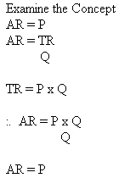MR
0 | 0 | 0 | - | -
1 | 1000 | 1000 | 1000 | 1000
2 | 1000 | 2000 | 1000 | 1000
3 | 1000 | 3000 | 1000 | 1000
4 | 1000 | 4000 | 1000 | 1000
5 | 1000 | 5000 | 1000 | 1000

Output | Price | TR | AR | MR
1 | 90
2 | 80
3 | 70
4 | 60
5 | 50
6 | 40
7 | 30
8 | 20
9 | 10

MARKET STRUCTURES
This refers to market arrangements or conditions which influence the behaviour and performance of firms in a particular industry.

Market structures are classified basing on the following aspects,
Number of firms in an industry, where there are many firms in the industry, its either perfect competition or monopolistic competition, where there are few firms, it is oligopoly and where there is only one firm, it is monopoly.

Degree of freedom of entry and exit, free entry and exit applies under perfect competition or monopolistic competition, restricted/limited entry applies under oligopoly and where entry is blocked, it is monopoly.

Degree of knowledge about the market conditions, where there is perfect knowledge about the market conditions by buyers and sellers, it is perfect competition but where there is imperfect knowledge about the market conditions, it is monopoly, oligopoly or monopolistic competition.

Influence on price determination, where firms have no influence on price determination (price takers) it is perfect competition, but where firms have some influence as regards to price determination, it is monopoly, oligopoly or monopolistic competition.

Degree of advertisement, where there is persuasive advertisement, it is either monopolistic competition or imperfect oligopoly, and where there is informative advertisement, it is monopoly, perfect competition or perfect oligopoly.

Nature of the demand curve, where the demand curve is perfectly elastic, it is perfect competition, where it is downward sloping but inelastic it is monopoly, where it is downward sloping but fairly elastic it is monopolistic competition and where it is kinked it is oligopoly.
Nature of the products produced, where similar products are produced, it is either perfect competition or perfect oligopoly but where differentiated products are produced, it is either monopolistic competition or imperfect oligopoly and where the commodity has no close substitutes, it is monopoly.

PERFECT COMPETITION
This is a market structure where there are many buyers and many sellers dealing in similar commodities.

CHARACTERISTICS /ASSUMPTIONS/FEATURES
- There are a large number of buyers and sellers such that none of them is in position to influence the price of the commodity. Each firm is free to put as much output as it wishes at the market price of the product. Therefore, the firm under perfect competition is a price taker.
- There is product homogeneity. Each firm produces and sells a homogeneous product so that no consumer has any preference for the product of any individual firm over others. This condition implies that firms under perfect competition must charge the same price.
- Firms are price takers and they sell at the same price determined by the whole industry because of producing similar commodities.
- There is perfect knowledge about market conditions by both buyers and sellers. They possess complete knowledge about the prices at which goods are being sold and bought; it is also assumed that they have perfect knowledge of the places where transactions take place. This condition implies that firms under perfect competition must charge the same price so that if one firm charges a higher price, then it will not sell anything.
- There is free entry and exit of firms. Firms have the freedom of movement into and out of the industry. Any firm with capital is free to join production and a firm with capital deficiency can leave the industry without any barrier; and any firm incurring losses can stop operating without any obstacle. The condition is applicable in the long run.
- There is perfect mobility of factors of production i.e. factors of production especially labour are assumed to be perfectly mobile between occupations and geographical areas due to the existence of perfect knowledge.
- There is no government interference. The government does not interfere in the price and output determination. Forces of demand and supply determine price and output.
- There are no transport costs incurred under perfect competition. This means that the raw materials, the firms and the consumers are in one place. This condition implies that firms under perfect competition must charge a uniform price.
- The demand curve is perfectly elastic because of producing similar commodities that are sold at a uniform price.
- There is no advertising because of product homogeneity; this therefore reduces the costs of production.
- The goal of the firm in a perfectly competitive market is profit maximization. Profits are maximized where MC is equal to MR.
NB. Pure competition is a market structure that considers all the assumptions of perfect competition apart from no transport costs, perfect mobility of factors of production and perfect knowledge about market conditions.
Question. Outline the features of pure competition.

SHORTRUN PROFIT MAXIMISATION UNDER PERFECT COMPETITION
In the short run, firms are able to make abnormal profits. The profits are maximized at a point where MC=MR (necessary condition).
The sufficient condition is that, MC curve should cut MR curve from below.

Demand curve for a firm and an industry
Diagram.
A firm will take the price established by the industry (ope) and maximize profits by producing the level of output oq₂ where MC=MR and MC is cutting MR from below.
The level of output oq₁ is at the point where MC=MR but a firm can still make more profits by increasing the level of output because each additional unit of output brings to the firm revenue which is greater than the cost.
The level of output oq₂ is the output that must be produced by a firm because MC=MR and MC cuts MR curve from below. Beyond that level of output, the cost incurred in producing additional unit of output is more than revenue from it.
The first condition for profit maximization is that, the firm must produce that level of output where MC=MR, however, this is only a necessary condition because from the above diagram, MC=MR at two points.
The second condition which is sufficient requires that, the MC curve must cut the MR curve from below.
Price/AR is constant because firms are price takers.
EQUILLIBRIUM POSITION OF A FIRM UNDER PERFECT COMPETITION WHILE MAXIMISING PROFITS.
The firm is generally said to be in equilibrium when it has no tendency to increase or decrease output. Under perfect competition the equilibrium position of a firm while maximizing profits is at a point where MC = MR.
Equilibrium of an industry is a tendency where new firms are neither entering into production nor old ones leaving.

SHORT RUN PROFIT MAXIMIZATION UNDER PERFECT COMPETITION

How are profits maximized in a perfect competition market in the short run? (2006-p.1)
Examine the advantages and disadvantages of a perfectly competitive market
In a perfect competition market in the short run, profits are maximized where MC = MR as shown below;
Diagram

Price (op) is determined at point X, where the output line touches the AR curve or output line touches the demand curve.
Output (o_{q}) is determined at point X, where MC = MR.
Costs (o_{c}) are determined at point y where the output line touches the average cost curve. (AC curve)

The firm earns abnormal/supernormal/pure profits represented by the shaded region CPXY, since average revenue is greater than average cost at equilibrium.

LONG RUN EQUILIBRIUM POSITION OF A FIRM UNDER PERFECT COMPETITION
In the long run, firms earn normal profits where AR is tangent to AC at the equilibrium output. If in the short run firms are earning abnormal profits, other firms will enter the industry resulting into increase in supply and a reduction in price. Firms will continue entering until normal profits are earned. The long run output is equal to the optimum output under perfect competition.
If in short run firms are incurring losses, some firms may leave the industry. The output therefore decreases and price increases. Firms continue leaving the industry until the existing firms earn normal profits.
How are profits maximized in a perfectly competitive market in the long run?
In the long run under perfect competition, profits are maximized at a point where MC=MR as shown below

DIAGRAM
Price (op) is determined at point e where the output line touches the AR curve.
The equilibrium output (oq) is determined at point e where MC=MR.
Costs (oc) are determined at point e where the output line touches the AC curve.
Since AR=AC at equilibrium, the firm earns normal profits.
Explain how a firm under perfect competition maximizes profits in the short run and long run.

THE BREAK-EVEN AND SHUT DOWN/CLOSE DOWN POINTS OF A FIRM:
Breakeven point is where a firm is earning normal profits. (where average revenue (AR) is equal to average cost (AC).
Or
It is where a firm neither makes abnormal profits nor incurs losses.
Whereas
The shut down point of a firm is where the firm covers only the average variable costs (AVC).
Or
It is a point below which a firm cannot cover its average variable costs. (AR=AVC)

Diagram

Questions:
Why may a firm continue to produce even when incurring losses?
Why may a firm continue to produce below the break-even?
Why may a firm continue to produce even when its AVCs are greater than its AC?

Preamble/Approach
- When it is a beginner firm and it has just started producing, the firm may hope to get profits in future.

- When it hopes to change management in order to attain efficiency and reduce average costs.

- When the firm has hope of getting a bank loan and credit facilities in order for it to improve its efficiency.

- When the firm fears to lose market and good will and may also wish to increase competition with rival firms.

- When the firm has hope of improving the marketing and pricing strategies in order to increase sales.

- When the firm has hope of reducing its man power and therefore reduces average costs in the long run.

- When the firm fears depreciation of machinery and it is not in position to sale fixed assets like buildings. Re-opening may also be very expensive.

- When the firm is government owned and its major objective is not profit maximization but to provide essential services.

- When the owner wants to maintain his/her reputation or to maintain employment to family members.

- When the firm fears to lose the source of raw materials to the rival firms.

- When the firm fears to lose the skilled man power which may force it to incur extra costs in training when re-opening.
- When the firm has hope of merging with another profit making firm.

- When a firm is a branch of another industry and its losses can be offset by sister firms.

- When there is fear of losing contracts and customers to other rival firms.

- When the high costs are of a seasonal or short run nature with hope to improve in the long run.

- When the owner is planning to improve on technology in order to reduce the average costs.

ADVANTAGES OF PERFECT COMPETITION
- There is efficient allocation of resources in the long run, since firms produce at the optimum level.

- Abnormal profits earned in the short run are used to expand the size of the firm and for carrying out research.

- It ensures increased output because of the large number of firms due to free entry.

- There is no wastage of scarce resources in advertising, since commodities are similar and there is perfect knowledge of market conditions by consumers.

- It ensures equitable distribution of income, because of the many firms that create more jobs that provide incomes to people.

- It creates more employment opportunities since there are many firms in the industry that hire more labour. This is due to free entry.

- Consumers enjoy high quality goods due to competition among firms.

- It ensures stable and fair prices in the market since all firms are price takers and there is perfect knowledge of the market conditions.

DISADVANTAGES OF PERFECT COMPETITION
- It assumes an ideal market situation that does not exist in the real world i.e. it is based on unrealistic assumptions e.g. no transport costs.

- Consumers have limited choice of commodities since commodities are similar.

- It may cause unemployment in the long run since inefficient firms are pushed out of the industry.

- There is duplication of services and economic activities because of producing similar commodities and this leads to wastage of resources.

- The absence of abnormal profits in the long run makes firms to be stagnant due to limited resources to carry out research.

- It cannot eliminate natural monopoly and business ownership of resources/capital since firms are many and deal in similar commodities.

- Firms cannot enjoy economies of scale due to limited expansion because of absence of abnormal profits in the long run.

SUPPLY CURVE OF A FIRM UNDER PERFECT COMPETITION
A supply curve of a firm under perfect competition is derived from points of intersection of the MC curve and the successive demand curves (AR) and its upward sloping. It is illustrated below.
(Diagram)

If the price is 0p₅ the quantity supplied is 0q5, where MC=MR5. A reduction in price to 0p4 reduces the quantity supplied to 0q4 where MC=MR4 etc.
With output 0q5, the firm makes abnormal profits, while with output 0q4, the firm makes normal profits, with output 0q3, the firm incurs losses. However output 0q3 will be produced regardless of the losses incurred. This is because the firm is still in position to cover the average variable costs. The firm will continue in production if it loses less than closing the firm completely.
The supply curve of a firm is exactly the MC curve for all levels of output equal to or greater than the level of output which corresponds to the minimum point of AVC.

Qn: State the relationship between AR and MR under perfect competition (1999-p.1)
AR=MR under perfect competition because the price is constant implying that the sale of an additional unit of output brings in the same amount as that brought in by each unit sold.

